**

* **Keep portable heaters three feet from anything flammable.**
* **Turn portable heaters off when leaving the room or going to sleep.**
* **Never use your oven to heat your home.**
* **Have your home heating system and chimney cleaned and inspected annually.**
* **Make sure your wood stove is properly installed and ventilated.**

Did you know?

In Minnesota in 2013, 10 percent   
of home fires

were caused   
by heating devices.

Most home fires occur in the winter and peak in January.

Most Minnesota heating fires occur   
in fireplaces and chimneys.

HEATING SAFETY

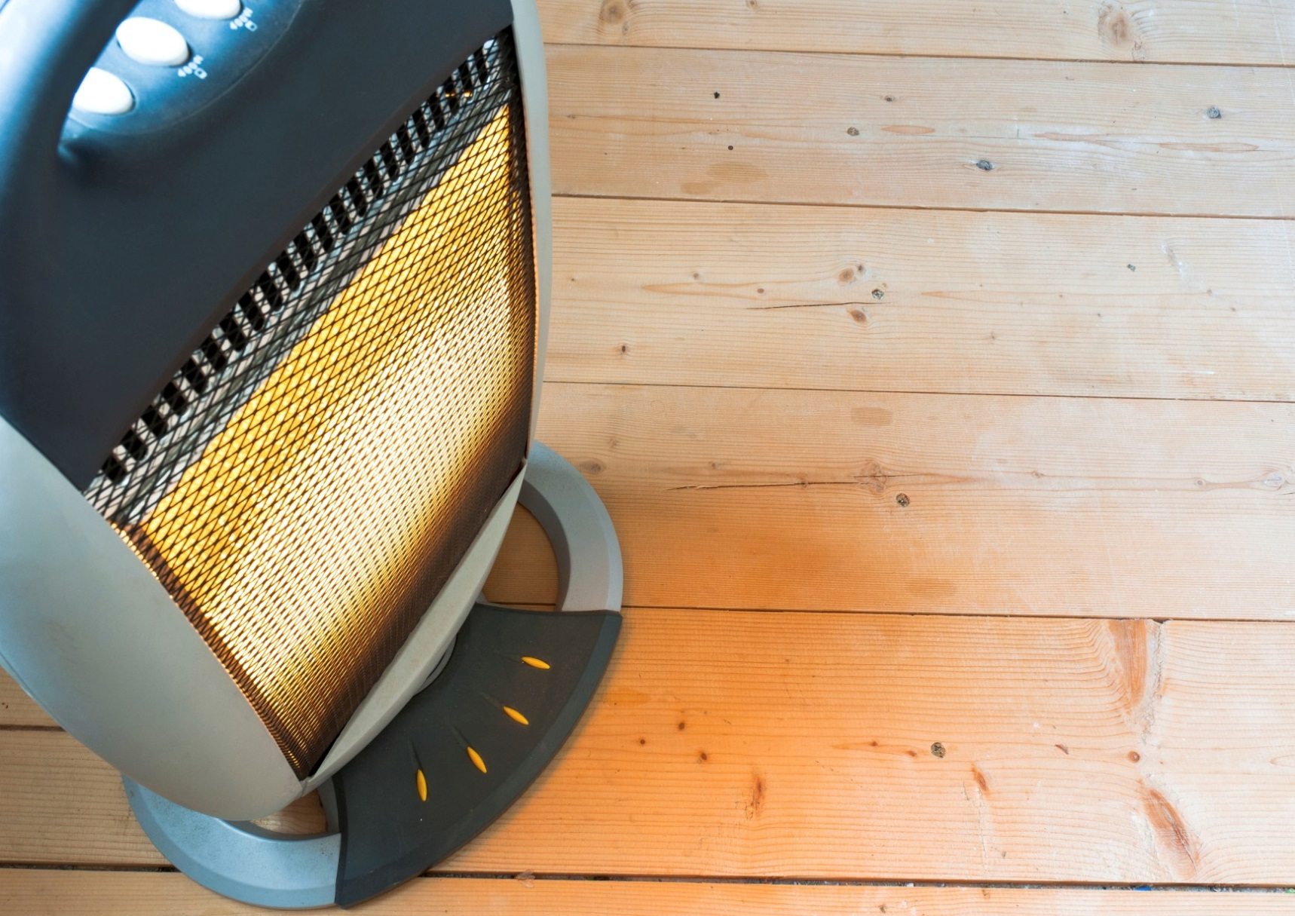

**YOUR DEPARTMENT WEBSITE**

**Your department street address Telephone: XXX-XXX-XXXX Fax: XXX-XXX-XXXX**