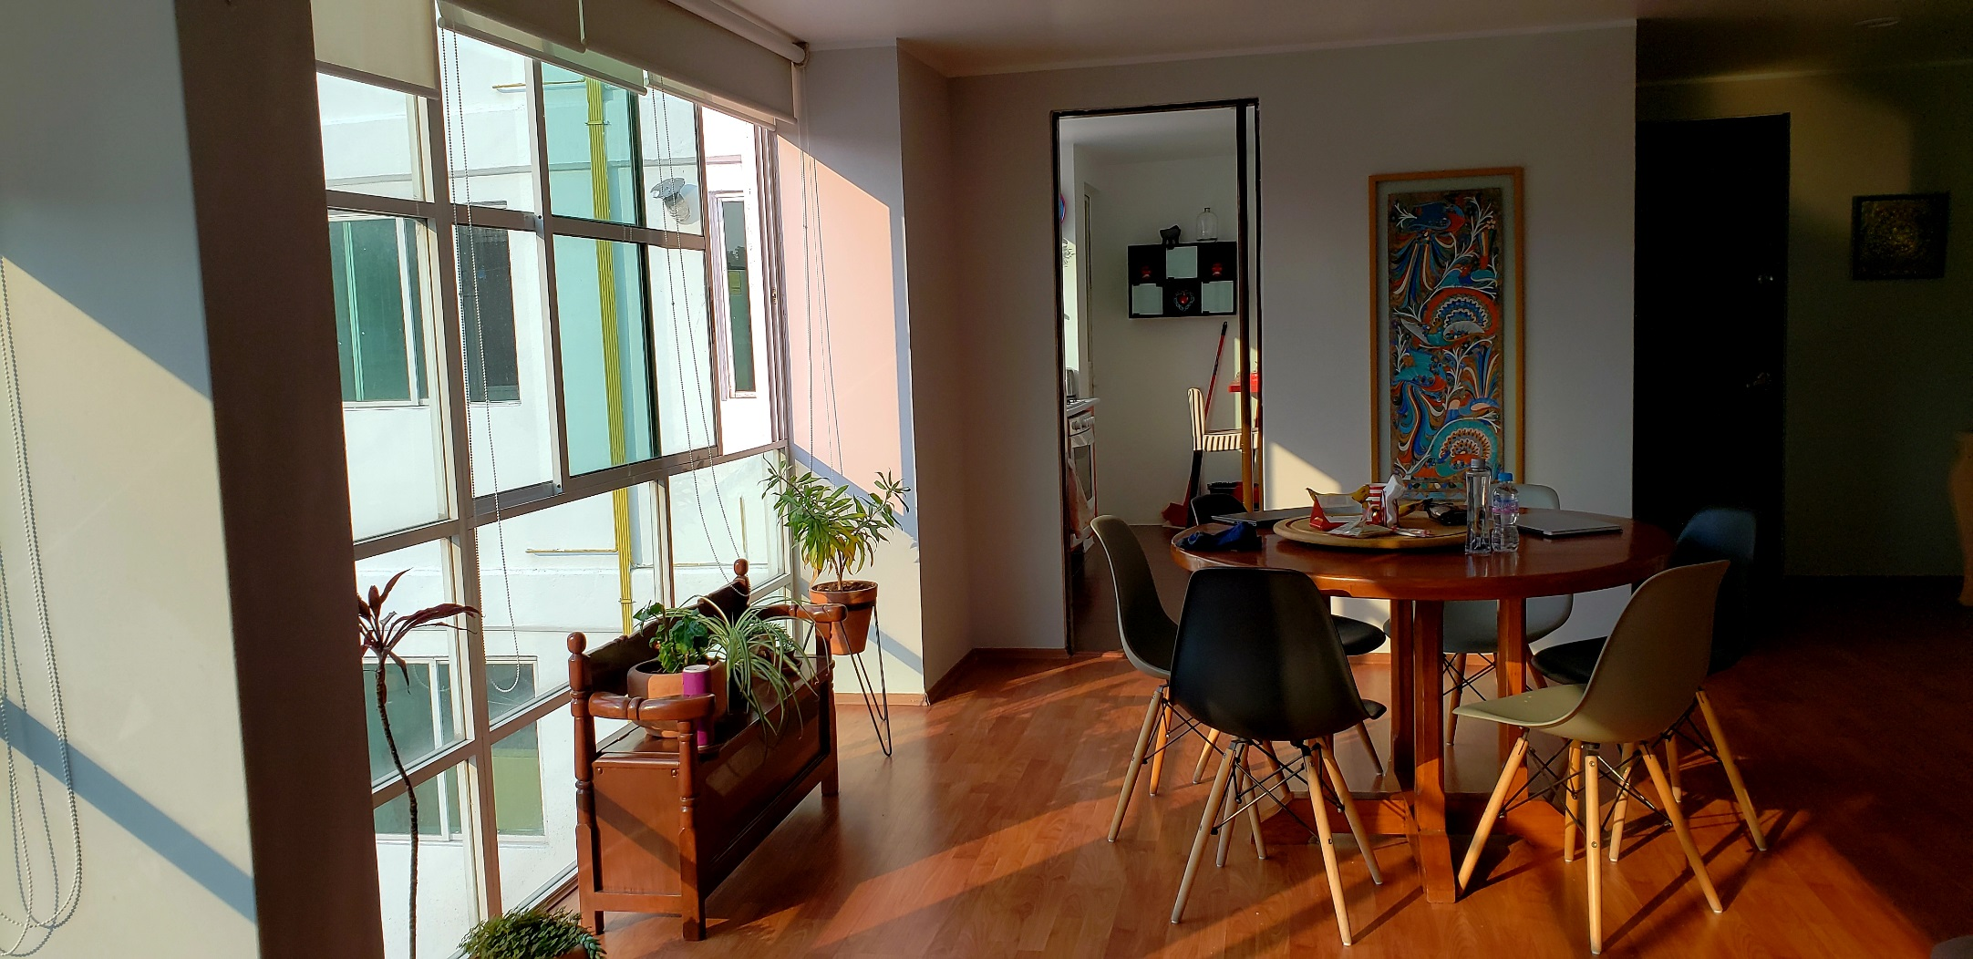

* **When booking, ask if there are working smoke and carbon monoxide alarms in every sleeping area and on every level of the home.**

* **Check that electrical outlets do not have adapters and extension cords are not being used.**
* **Everyone knows how to call for emergency services and has a safe escape plan.**
* **Check that all exits — including windows — are clear, open properly and are not barred.**

HOME AWAY FROM HOME

Did you know?

Personal vacation rental housing is not regulated the same way as hotels.

It is your responsibility to make sure there an emergency shelter   
in the event   
of threatening weather.

Be in charge of your own safety while traveling and follow these safety tips.

**YOUR DEPARTMENT WEBSITE**

**Your department address Telephone: XXX-XXX-XXXX Fax: XXX-XXX-XXXX**