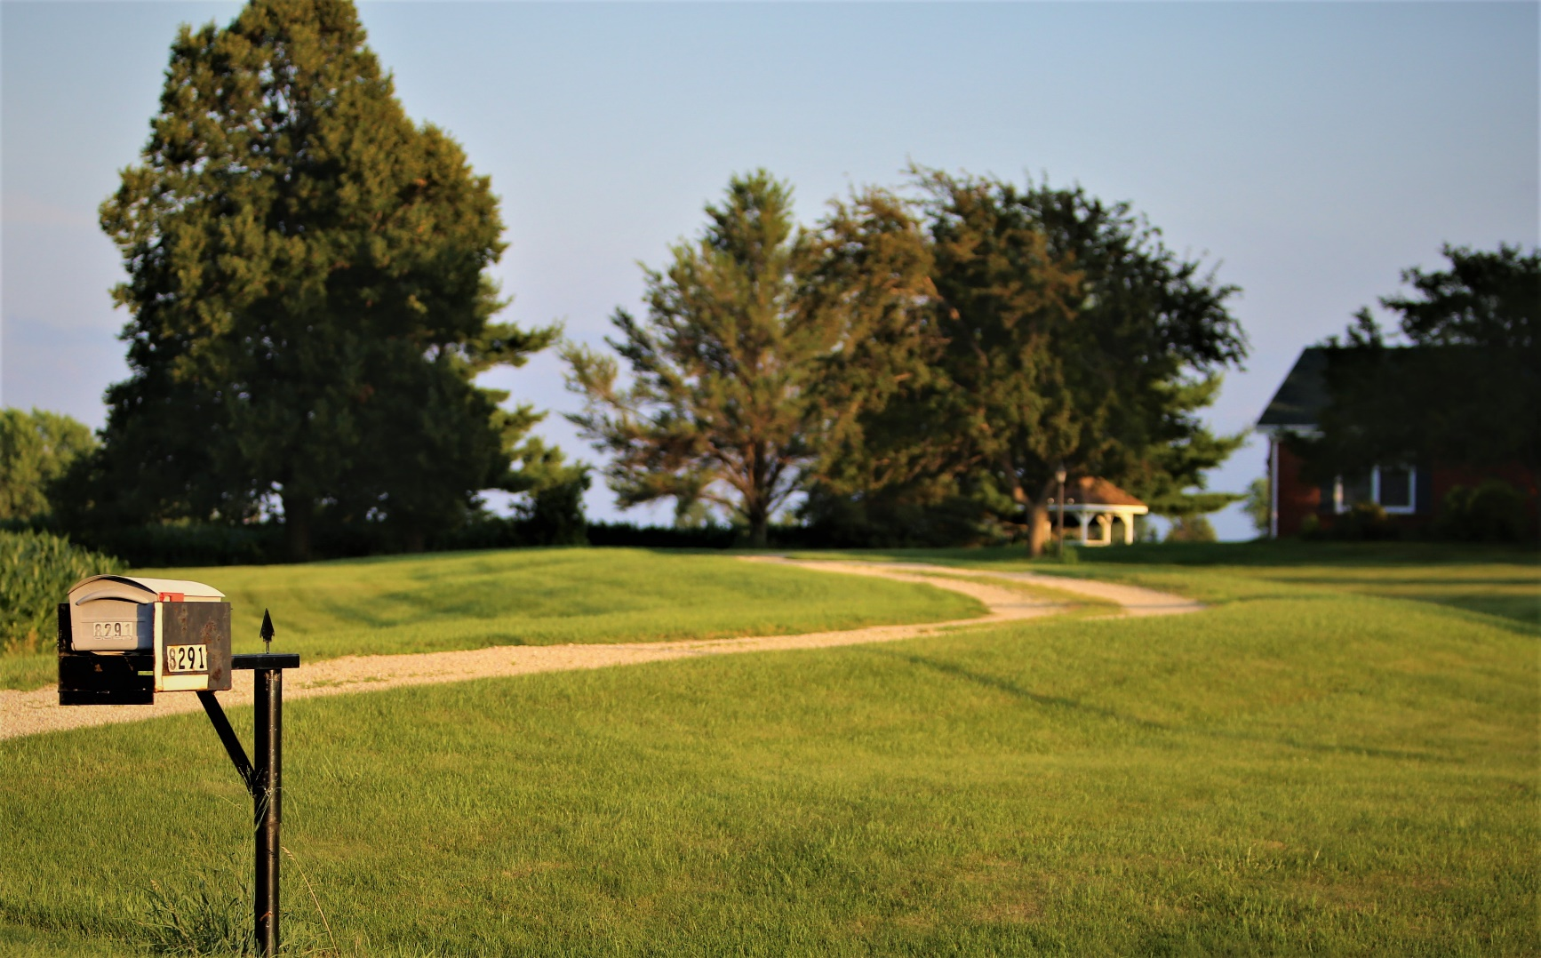

* **House numbers should be visible from the street.**

* **If your house is set back, affix numbers to a mailbox or post that can be seen from the public road.**
* **Trim any greenery and remove decorations that may block clear view of your address.**
* **If possible, post your address near a porch light, or at least use reflective numbers.**
* **House numbers should be at least 4 inches tall.**

Did you know?

Firefighters can’t help if they   
can’t find you.

Your safety in an emergency depends on responders’ ability to find   
you quickly.

Saving lives and property can come down to a matter   
of seconds.

Emergency vehicles need to be able to see your address   
day or night.

ADDRESS SAFETY TIPS

**YOUR DEPARTMENT WEBSITE**

**Your department address Telephone: XXX-XXX-XXXX**

