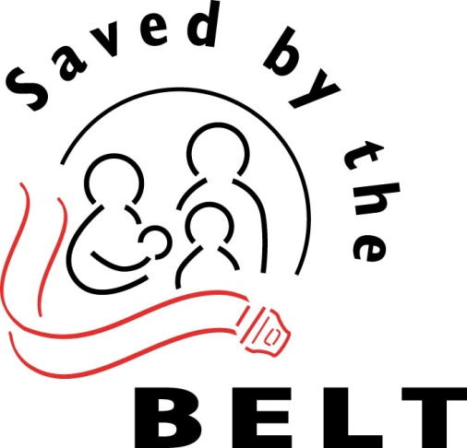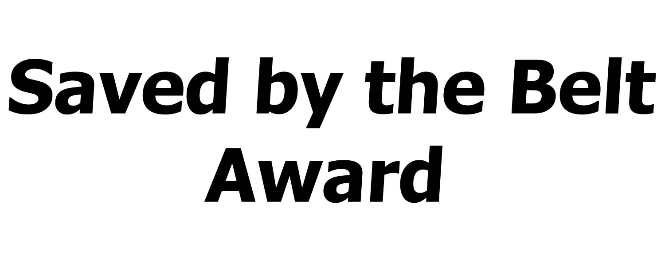
Congratulations! The [CITY/COUNTY/STATE PATROL] of [CITY/ COUNTY/STATE PATROL DISTRICT NUMBER] commends you for your
life-saving choice and for the strong example you provide to others on the importance of buckling up. You are living proof that safety belts save lives!

Presented to: On:

[Title, Name, Agency Name] [Title, Name, Agency Name/City Official Name, etc.]

