**

* **Muab cov qhov cub siv kom sov tsev uas nqa tau mus los (portable heaters) tso kom deb peb feet ntawm tej khoom ua txais tau hluav taws zoo.**
* **Muab cov qhov cub siv kom sov tsev uas nqa tau mus los tua thaum tawm ntawm chav nyob mus los yog thaum mus pw.**
* **Tsis yeem siv lub qhov cub ua noj los ua kom koj lub tsev sov.**
* **Kuaj thiab tu txoj kev tso cua sov rau koj lub tsev thiab tus kav tso pa taws tawm (chimney) txhua xyoo.**
* **Ua kom paub tseeb tias muab koj lub qhov cub rauv taws teeb kom yog thiab muaj cua khiav tau mus los.**

Koj puas paub?

Nyob hauv Minnesota hauv xyoo 2013, 10 feem pua ntawm cov tsev kub hnyiab yog kub los ntawm cov cuab yeej siv ua kom sov tsev.

Cov tsev kub hnyiab feem ntau yog tshwm sim thaum lub caij ntuj no thiab muaj ntau tshaj thaum lub Ib Hli Ntuj.

Cov kev ua kom sov tsev es ua rau tsev kub hnyiab hauv Minnesota feem ntau yog tshwm sim hauv cov qhov cub rauv taws thiab cov kav tso pa taws tawm.

KEV KAJ HUV RAU KEV UA KOM TSEV SOV

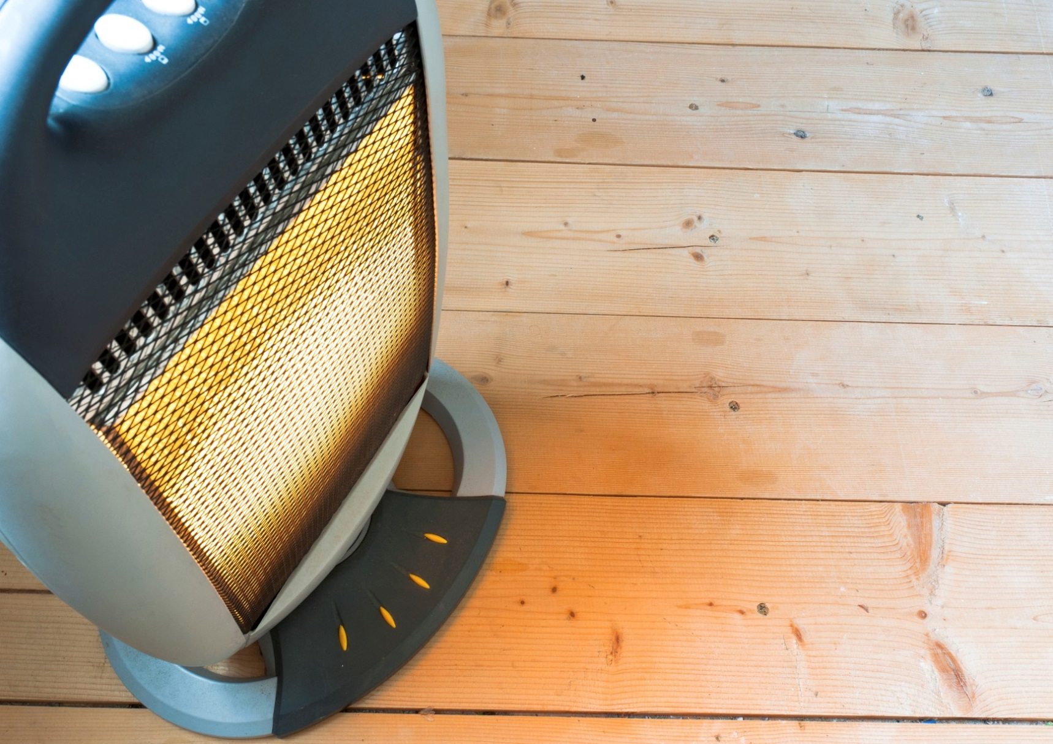

**YOUR DEPARTMENT WEBSITE**

**Your department street address Xov tooj: XXX-XXX-XXXX Fax: XXX-XXX-XXXX**