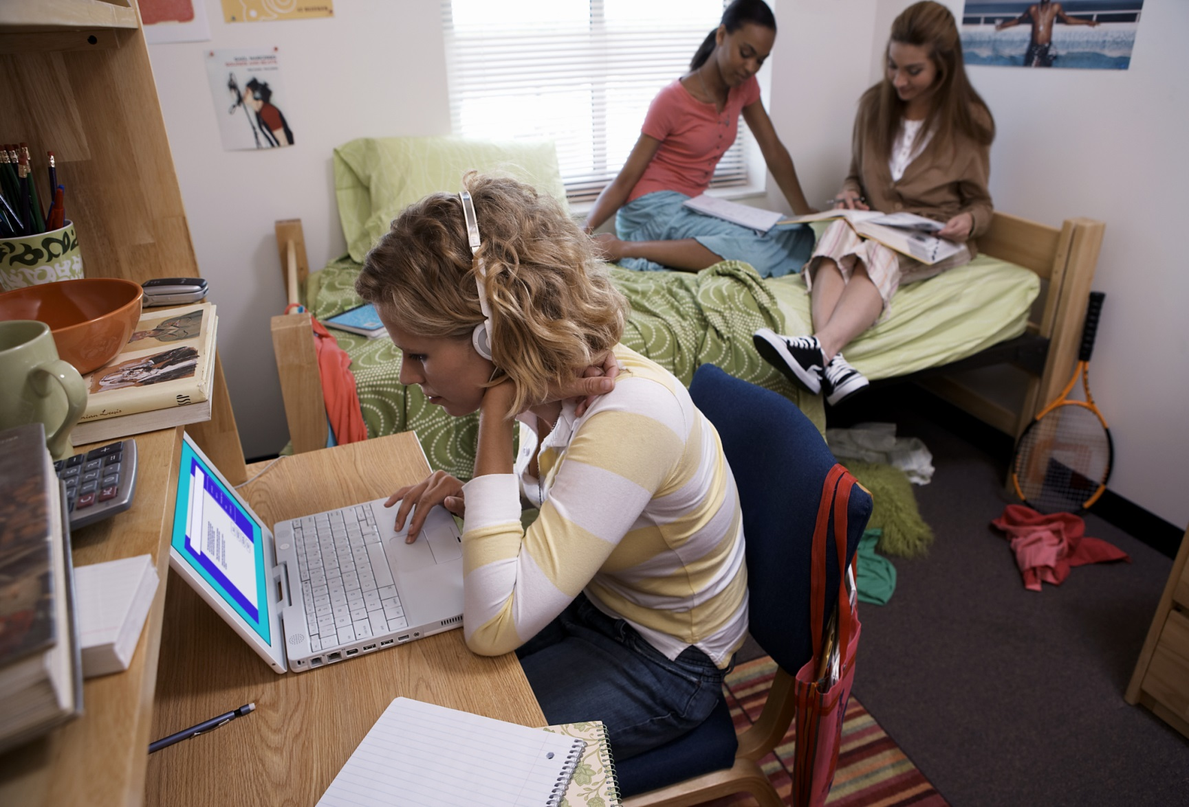

* **Warkaad waxqurixayso isticmaal shamacyo aan olol lahayn.**

* **Marnaba ha iska dhega-tirin qaylo dhaanka dabka (digniin dab). Meesha ka bax oo dibadda joog markay maqasho qaylo dhaanka dabka.**
* **Qorshe aad uga baxsato dabka ha kuu degsannaado kaasoo leh laba dariiq oo lagaga baxo meesha.**
* **Iska hubi inayna meelaha aad ka baxayso iyo meelaha aad marayso ayana wax isdhex-oollin; oo iska hubi inay daaqadaha/albaabbadyu si fudud furmaan.**
* **Markastaaba jikada sii joog goorta aad wax karinayso; waligaa wax ha karin markaad daallan tahay ama maandooriye aad isticmaashay.**

Ma ogtahay?

Afar ka mid ah shantii dhimasho ee ku timaad dabka ayaa ka dhaca guriyaynta ka inta baxsan xerada kulliyadda, sida laga soo xigtay Campus Firewatch.

Sababaha ugu badan ee dadbaka ka kaca xerooyinka ayay ka mid yihiin wax karinta, dembiga dab kicinta iyo cabbis xil-kas la'aanta ah.

Dababka ka dhaca xerooyinka tacliinta ayaa ah mid inta badan dhaca inta u dhexeysa 5 iyo 11 p.m. iyo toddobaad dhammaadka.

BADBAADADA DABKA XERADA TACLIINTA

**YOUR DEPARTMENT WEBSITE**

**Your department address Telefoonka: XXX-XXX-XXXX Faakis: XXX-XXX-XXXX**