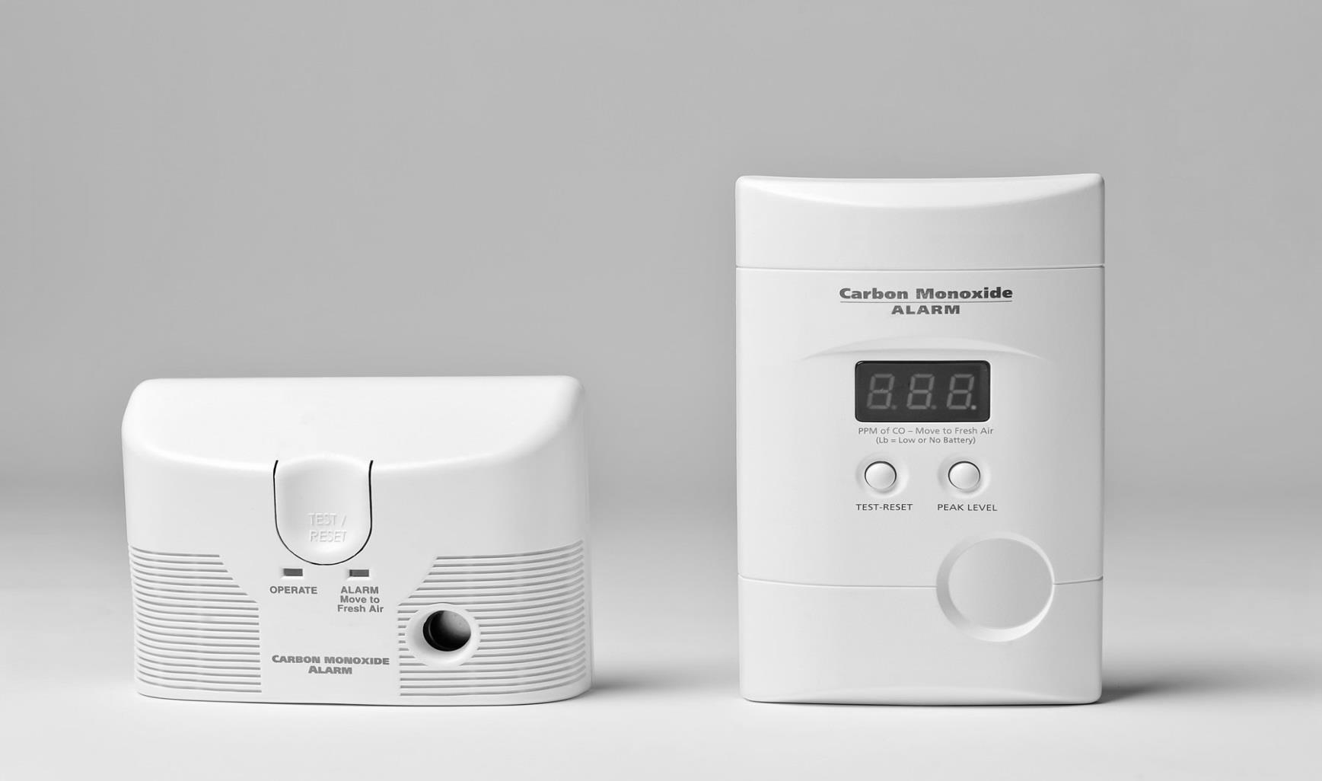

Did you know?

Carbon monoxide   
is an odorless, tasteless and invisible gas.

Signs of CO poisoning include headache, nausea, fatigue, vomiting and disorientation.

Cooking and heating units that burn fuel and are not properly ventilated or malfunction can   
be a source of CO   
in the home.

* **Carbon monoxide alarms should be installed within 10 feet of each sleeping room or inside each sleeping room.**

* **Test CO alarms monthly.**
* **If a CO alarm sounds and you feel ill, call 911 immediately. If you feel fine, open windows and doors and your utility company.**
* **Clear snow and debris from furnace, dryer, fireplace or oven vents around your home to prevent a CO buildup.**

CO ALARMS

WHAT YOU NEED TO KNOW ABOUT:

**YOUR DEPARTMENT WEBSITE**

**Your department address Telephone: XXX-XXX-XXXX Fax: XXX-XXX-XXXX**