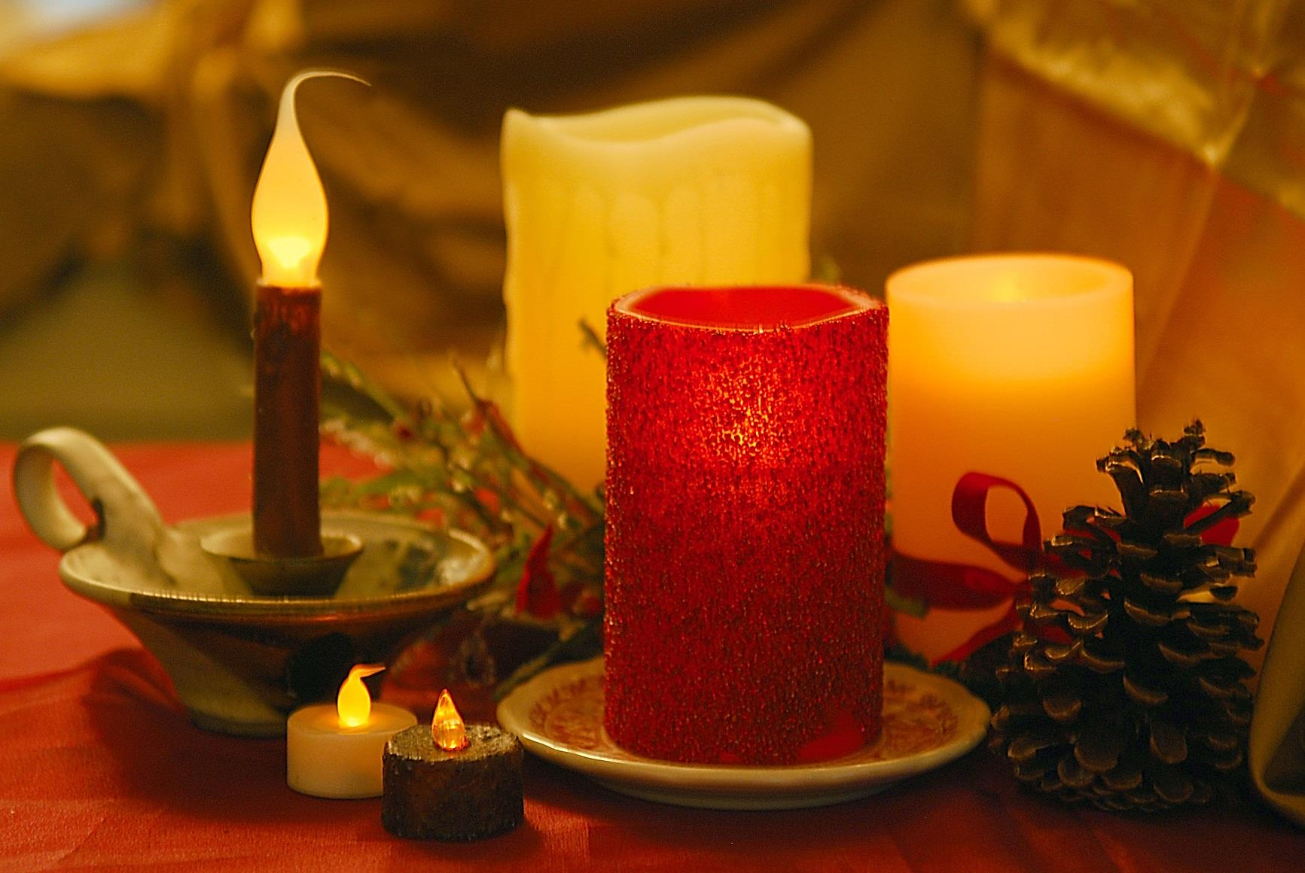

Did you know?

Two of every five home decoration fires are started   
by candles.

Candles and open flames are the third leading cause   
of Minnesota structure fires.

Nationally, residential candle fires peak in December.

* **Choose flameless candles. Most offer the same flicker effect as real candles and come in scented varieties.**

* **Keep traditional candles in a sturdy container that cannot be tipped over.**
* **Extinguish candles before leaving the room or going to sleep.**
* **Use flashlights — not candles — for emergency lighting if the power goes out.**

CANDLE SAFETY

**YOUR DEPARTMENT WEBSITE**

**Your department street address Telephone: XXX-XXX-XXXX Fax: XXX-XXX-XXXX**

