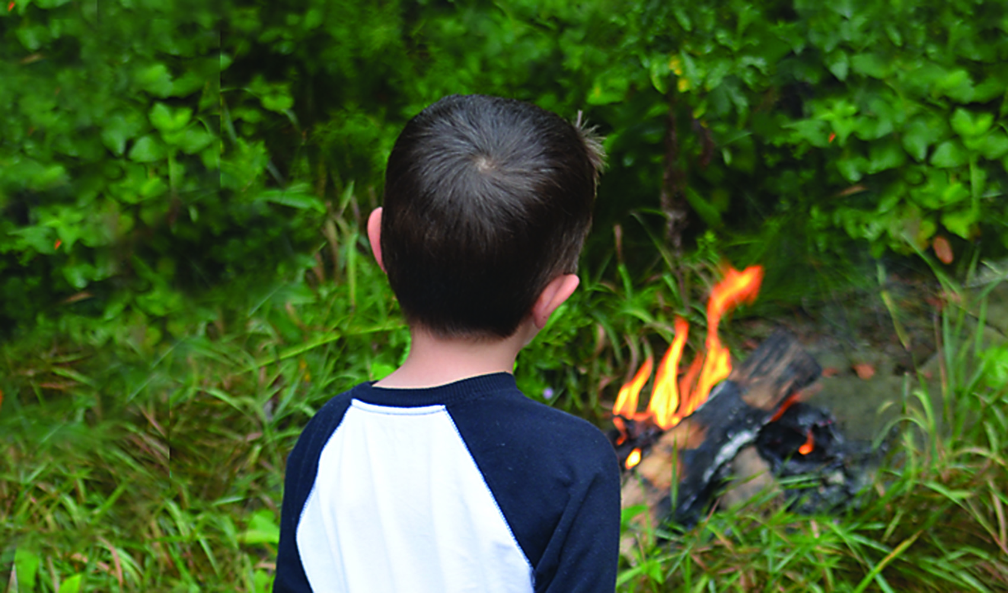

Koj puas paub?

Cov me nyuam hnub nyoog 10 xyoo mus txog 17 xyoo yog thaj tsam li ntawm 50 feem pua ntawm cov neeg raug txhom rau kev txhob txwm zes taws.

Hauv xyoo 2013, cov me nyuam yog cov pib ua hluav taws kub hnyiab 300 zaug hauv Minnesota.

Tab txawm ib tug me nyuam yuav pib zes taws ib nyuag qhov me me xwb los, nws yeej yog ib qho teeb meem loj. Hluav taws yuav muaj peev xwm ua rau tej khoom ntiag tug puas tsuaj, ua rau neeg raug mob thiab tuag.

Nws muaj kev pab kom nres tau txoj kev coj li no.

* **Ua ib tug qauv zoo. Siv hluav taws kom zoo thiab tham nrog koj cov me nyuam hais txog tej xwm txheej ntawm hluav taws kub.**

* **Ceev tej cuab yeej siv rau hluav taws kom zoo thiab muab xauv cia.**
* **Saib tej cim uas pom zoo li yog siv hluav taws tsis yog chaw nrog rau tej qho hluav taws kub uas piav tsis tau los yog tej cheeb tsam uas yaj ntawm tej khaub ncaws, rooj tog, khoom me nyuam yaus ua si, ntawv thiab sab nraum zoov.**
* **Tham nrog koj tus me nyuam yog koj pom muaj cov cim uas yog siv hluav taws tsis yog chaw thiab hu rau 1-800-500-8897 kom pab.**

TIV THAIV KEV ZES TAWS KUB NTAWM COV HLUAS

**sfm.dps.mn.gov**

**445 Minnesota St., Suite 145, St. Paul, MN 55101 Xov tooj: 651-201-7200 Fax: 651-215-0525**