HOW MANY KIDS START FIRES IN MINNESOTA?
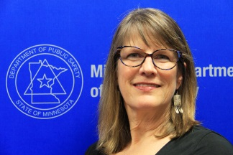
By Kathi Osmonson
State Fire Marshal Division
Youth firesetting prevention and intervention specialist

More children than you might think are involved with starting fires.

How many children have you seen running away from a fire scene at a playground or a porta-potty? Are these fires entered on the report as playing with ignition source or age as a factor, or simply undetermined?

An in depth study conducted by the Department of Public Safety revealed that at least 500 children were involved win starting 300 fires in 2013 alone. The study was based on NFIRS reporting and independent youth firesetting prevention & intervention (YFPI) programs. Many of the YFPI reports did not appear on NFIRS because they were referred by sources other than a fire call such as parents and teachers.

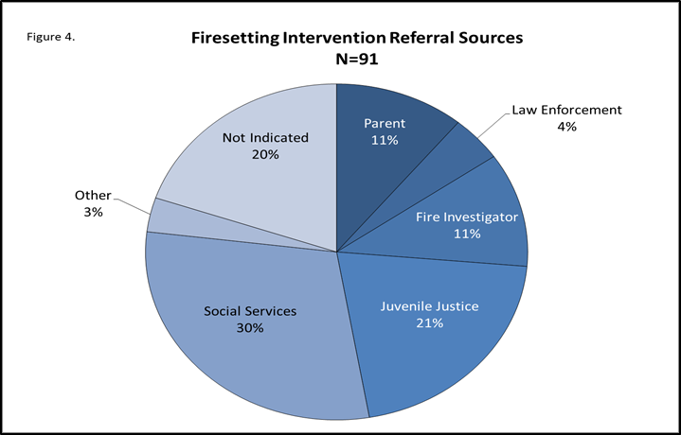

If you would like to read the entire report, you can find it by logging into: https://dps.mn.gov/divisions/sfm/mfirs/Pages/Reporting_Statistics.aspx
Please let us know if you have additional data that is not listed in the report.

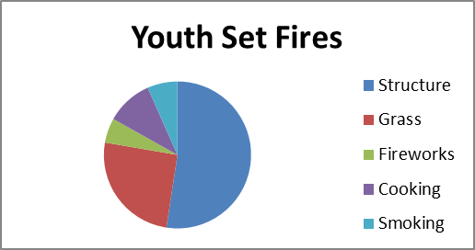
The types of fires these kids were involved in vary mostly between grass fires or other outside fires and structure fires. Youth smoking and cooking fires were also included in the study because these kids could also benefit from intervention education.
Structure fires may be misrepresented as the highest risk area for youth set fires, but the United States Fire Administration states that most youth start fires outside, where they are less likely to get caught. Structure fires are where these fires are noticed and often get out of control.

Please report any youth you find starting fires to a local YFPI program or call 1-800-500-8897. If they simply run away, please make a note of that also so we can gather accurate statistics.

The problem is larger than you might think.

###

