Minnesota Board
of Peace Officer
Standards and Training
1600 University Avenue, Suite 200
Saint Paul, MN 55104-3825
(651) 643-3060 • Fax (651) 643-3072
www.post.state.mn.us
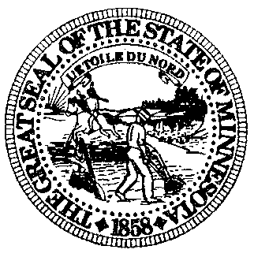

TRAINING COMMITTEE MEETING AGENDA

1600 University Avenue, Suite 200

St. Paul, Minnesota 55104-3825

Thursday, April 9, 2015
10:00 AM

- Call to Order
- Approval of Agenda ACTION
- Approval of July 9, 2014, Training Committee Meeting Minutes (Attachment) ACTION
- Announcements
- 2015 Professional Peace Officer Education Learning Objectives (attachment) ACTION
- Suvey on PPOE Coordinator Qualifications at Universities (Attachment)
- Survey of License Eligible Candidates (Attachment)
- Testing Accommodations Form (Attachment) ACTION
- Survey of PPOE schools regarding admissions standards and program operation practices (Attachment to Follow)
- For-Profit Schools in the News (Attachments)
- Adjournment

