Minnesota Board
of Peace Officer
Standards and Training
1600 University Avenue, Suite 200
Saint Paul, MN 55104-3825
(651) 643-3060
www.post.state.mn.us
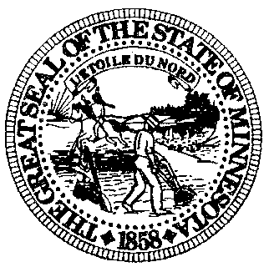

Ensuring Police Excellence and Improving Community Relations Advisory Council​

MEETING AGENDA (Revised)
1600 University Avenue, Suite 200
Saint Paul, Minnesota
October 14, 2020
10:00 a.m.
This meeting will be held online due to COVID-19 emergency, a link to observe the meeting will be on the POST website prior to the meeting.

NOTE: The meeting invite will be scheduled to start at 9:45a.m. to allow for some practice time and members to ensure their connectivity.

- Call to Order
- Welcome by POST Board Executive Director.
- Brief housekeeping.
  - Procedure for conducting business in virtual meeting
  - Introduction of Abby Brown (council liaison)
  - Procedure for submitting per diems
- Approval of the Agenda ACTION
- Review purpose and scope of the Council (Presentation by Representative Mariani)
- Introductions
- Orientation/overview of the POST Board
  - Mission and history
  - Current activities
- Choose a Chairperson
- Round table
- Schedule next meeting and adjournment

