WINTER HAZARD AWARENESS WEEK

NOVEMBER 13-17, 2023

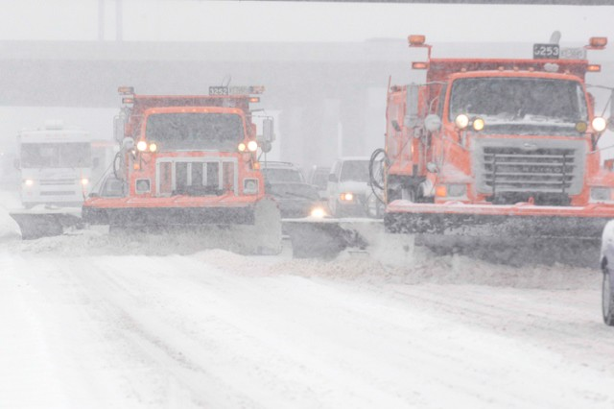
Minnesota summers are cherished times. But as the season turns to fall,
and the air turns crisp, we know a Minnesota winter is soon on the way.
As we get out the gloves and boots,
it is time to refresh our winter safety knowledge and skills - and get prepared.

That’s why the Minnesota Department of Public Safety division of Homeland Security and Emergency Management (DPS-HSEM), in collaboration with the National Weather Service, sponsors the annual Winter Hazard Awareness Week public information campaign each year.

The week features an intense news and social media information campaign that highlights daily topics related to winter weather safety. The HSEM Winter Weather Safety website offers additional information, checklists, and resources to assist in local education efforts throughout the season. We encourage people, families, businesses, and organizations to use the information to review, refresh and share their winter safety knowledge and habits.

WINTER HAZARD AWARENESS WEEK TOPICS

- Monday, Nov. 13:
Winter Weather Overview – Ice storms, blizzards, sub-zero temperatures, winter weather watches warnings and wind chill.

- Tuesday, Nov. 14:
Outdoor Winter Safety – Safety on ice, snowmobile safety, hypothermia and frostbite.

- Wednesday, Nov. 15:
Winter Fire Safety – Winter and holiday fire safety, alternative heat sources, smoke detectors, cooking safety, candles and decorations.

- Thursday, Nov. 16:
Indoor Winter Safety – Carbon monoxide, radon, mold and general home care.

- Friday, Nov. 17:
Winter Driving – Auto safety, snowplows, road conditions, using 511, winter driving tips and car survival kits.

Be sure to visit the HSEM website, Facebook and Twitter pages for Winter Hazard Awareness Week tips and other best practices.
Find additional information on the National Weather Service’s winter safety webpage.

