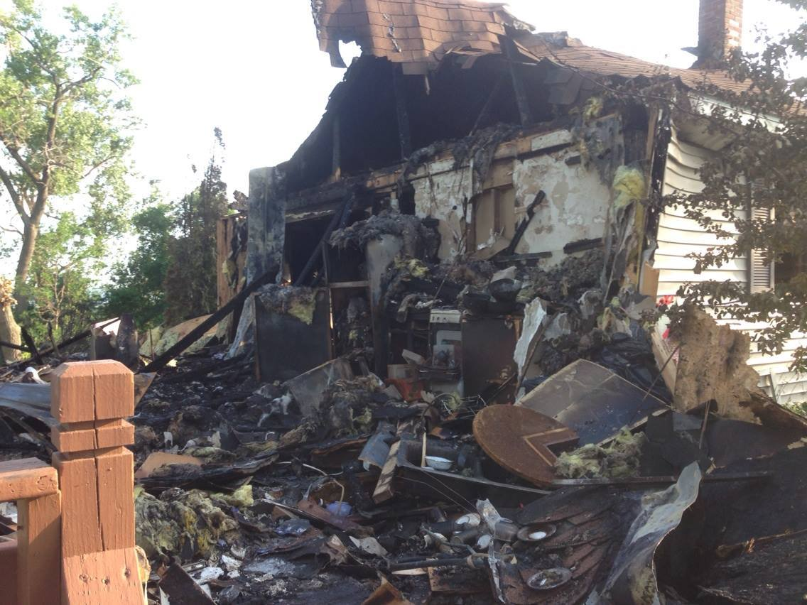

* **Contact a local disaster relief service like the American Red Cross.**

* **Check with local fire officials to make sure your home is safe to re-enter.**
* **Contact your insurance company.**
* **Try to find valuable documents like driver’s licenses, Social Security cards and credit cards.**
* **Let local police know the home will be vacant.**

AFTER THE FIRE?

Did you know?

Firefighters may need to cut holes in walls or ceilings to ensure the fire is out. They also may cut holes into the roof to ventilate hot gases.

You should keep receipts and records on any money spent related to fire loss.   
The information may be requested by   
your insurance company.

WHAT SHOULD YOU DO

**YOUR DEPARTMENT WEBSITE**

**Your department address Telephone: XXX-XXX-XXXX Fax: XXX-XXX-XXXX**