**

* **Makiinada guriga lagu kululeeyo ee la qaadan karo ka fogee saddex fiit wixii kasta ololi kara.**
* **Makiinada guriga lagu kululeeyo ee la qaadan karo qolka markaad ka tageyso ama aad seexanayso iska demi.**
* **Marnaba foornadaada (ofankaaga) ha u isticmaalin inaad ku kulaylisato gurigaaga.**
* **Sannad kasta ha laguu nadiifiyo oo ha la eego nidaamka kulaylinta iyo jimniga gurigaaga.**
* **Iska hubi inuu istoofkaaga alwaaxa ka samaysani sida habboon u rikiban yahay oo hawadu uga baxayso.**

Ma ogtahay?

Gudaha gobolkan Minnesota sannadkii 2013, boqolkiiba 10 ee guriga dabka qabsaday ayaa waxaa sababay oo ugu qalabyada guriga lagu kululeeyo.

Inta badan dababka guriga qabsada waxay kacaan xilliga qaboobaha oo ay ugu badan yihiin bisha Janaayo.

Inta badan dadbka ka dhaca gobolka Minnesota wuxuu ka bilowdaa goobta dabka iyo jimniga.

BADBAADADA KULAYLINTA

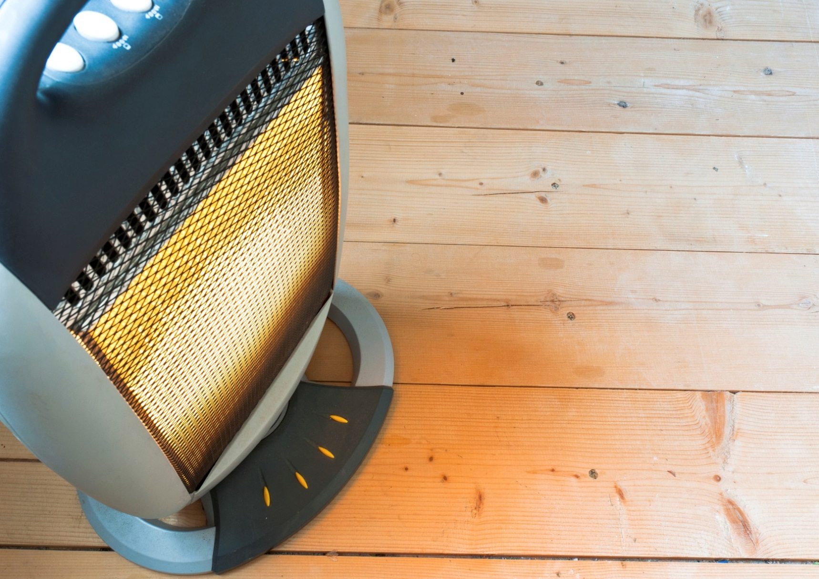

**YOUR DEPARTMENT WEBSITE**

**Your department address Telefoonka: XXX-XXX-XXXX Faakis: XXX-XXX-XXXX**