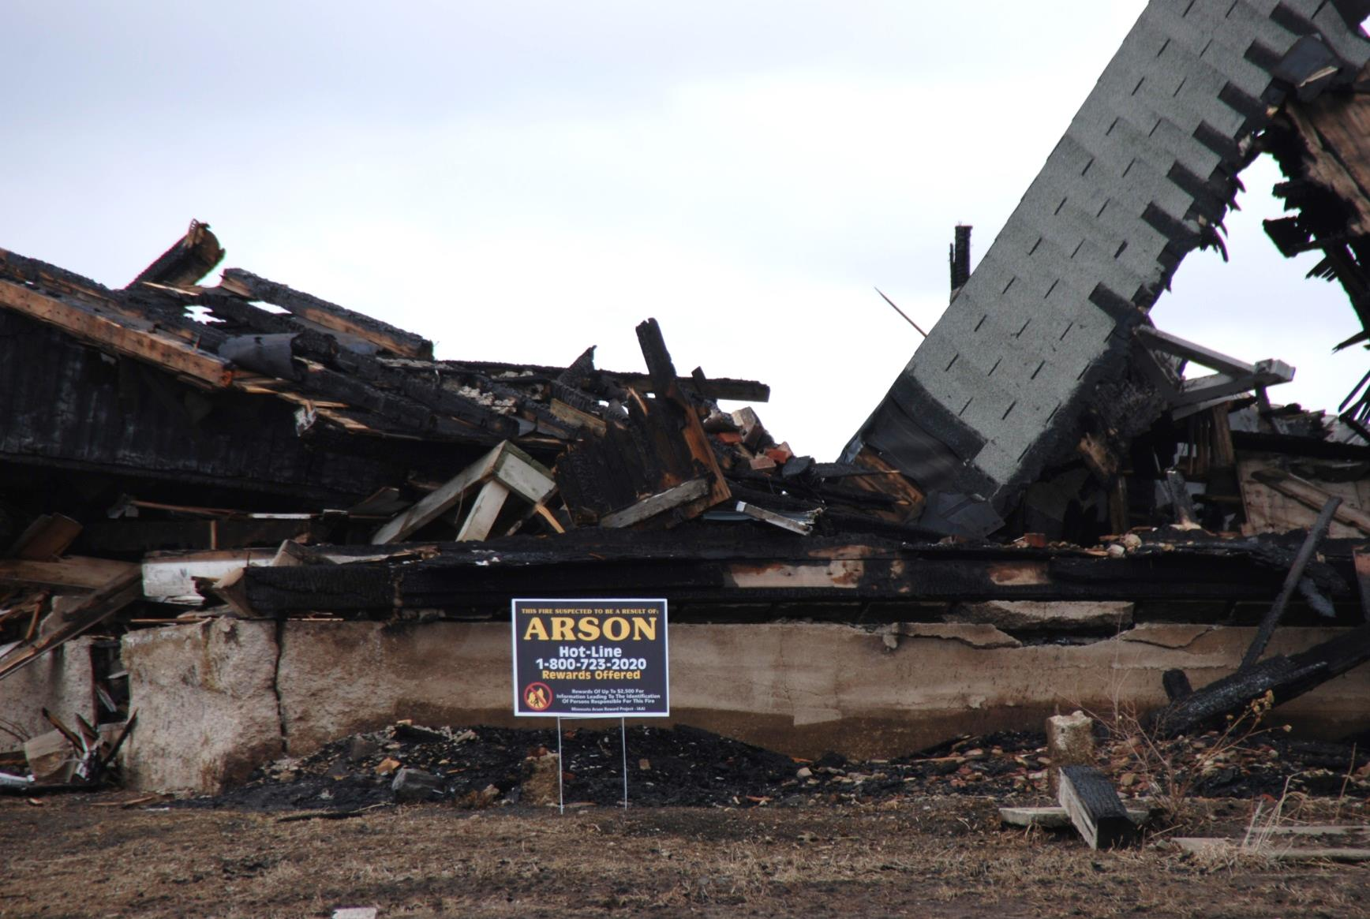

* **Remove overgrown vegetation, brush and trash from your property.**

* **Pay attention to vehicles in disrepair on your property. Car fires can spread quickly.**
* **Continue to evaluate the space around your home and consider removing items that may burn.**
* **Get to know your neighbors and help each other keep an eye on the neighborhood.**
* **Call the arson hotline at 1-800-723-2020 with info about any suspicious fires.**

Did you know?

Incendiary describes any fire that is intentionally set. An arson fire is an example of an incendiary fire but not all incendiary fires are arson.

Over the last five years there was an average of 1,137 incendiary fires in Minnesota.

There were 170 residential incendiary fires in 2013 in Minnesota.

ARSON PREVENTION

**YOUR WEBSITE**

**Your Department Address Telephone: XXX-XXX-XXXX Fax: XXX-XXX-XXXX**