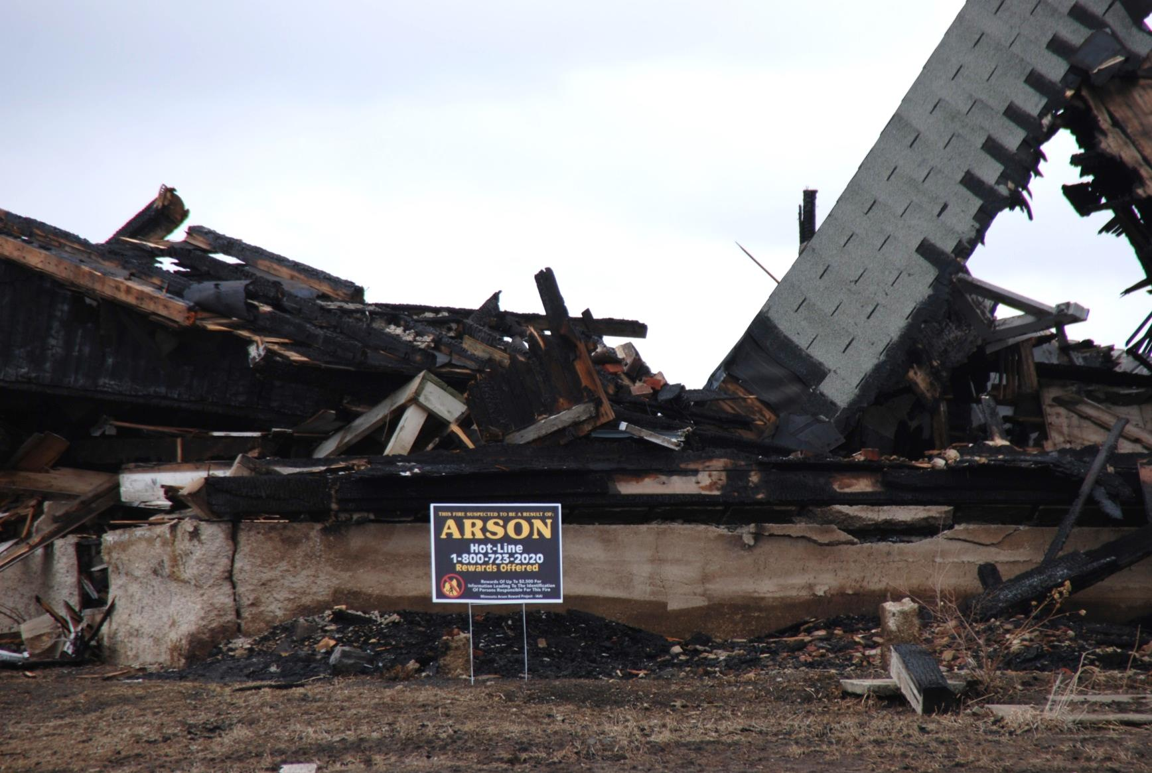

Koj puas paub?

Ua hluav taws kub yog piav txog cov hluav taws uas txhob txhwm zes taws rau kom kub. Ib qho txhob txwm zes taws rau kom kub yog ib qho piv txwv ntawm qhov ua hluav taws kub tab sis kuj tsis yog tag nrho cov kev ua hluav taws kub yog qhov txhob txwm zes taws rau kom kub.

Tsib lub xyoo dhau los nws muaj txog ntawm 1,137 qhov ua hluav taws kub nyob hauv Minnesota.

Nws muaj txog 170 zaug ua hluav taws kub tsev hauv xyoo 2013 hauv Minnesota.

* **Tshem tej nroj tsuag uas fab, tej me nyuam ntoo thiab khib nyiab tawm ntawm koj thaj chaw mus.**

* **Xyuas cov tsheb uas kho tsis tau lawm nyob ntawm koj thaj chaw kom zoo. Cov tsheb kub hnyiab yuav kis tau sai heev li.**
* **Ntsuam xyuas thaj chaw ib ncig ntawm koj lub tsev mus ntxiv thiab muab yam uas yuav kub hnyiab tau tshem tawm.**
* **Xyuas kom paub cov neeg nyob ze koj thiab sib pab saib xyuas tej chaw nyob ib ncig sawv daws.**
* **Hu rau txhob txwm zes hluav taws rau kom kub tus xov tooj ntawm 1-800-723-2020 yog paub txog tej qho hluav taws kub uas xoom xaim muaj tej yam txawv.**

TIV THAIV KEV TXHOB TXWM ZES TAWS KOM KUB

**YOUR WEBSITE**

**Your Department Address Xov tooj: XXX-XXX-XXXX Fax: XXX-XXX-XXXX**