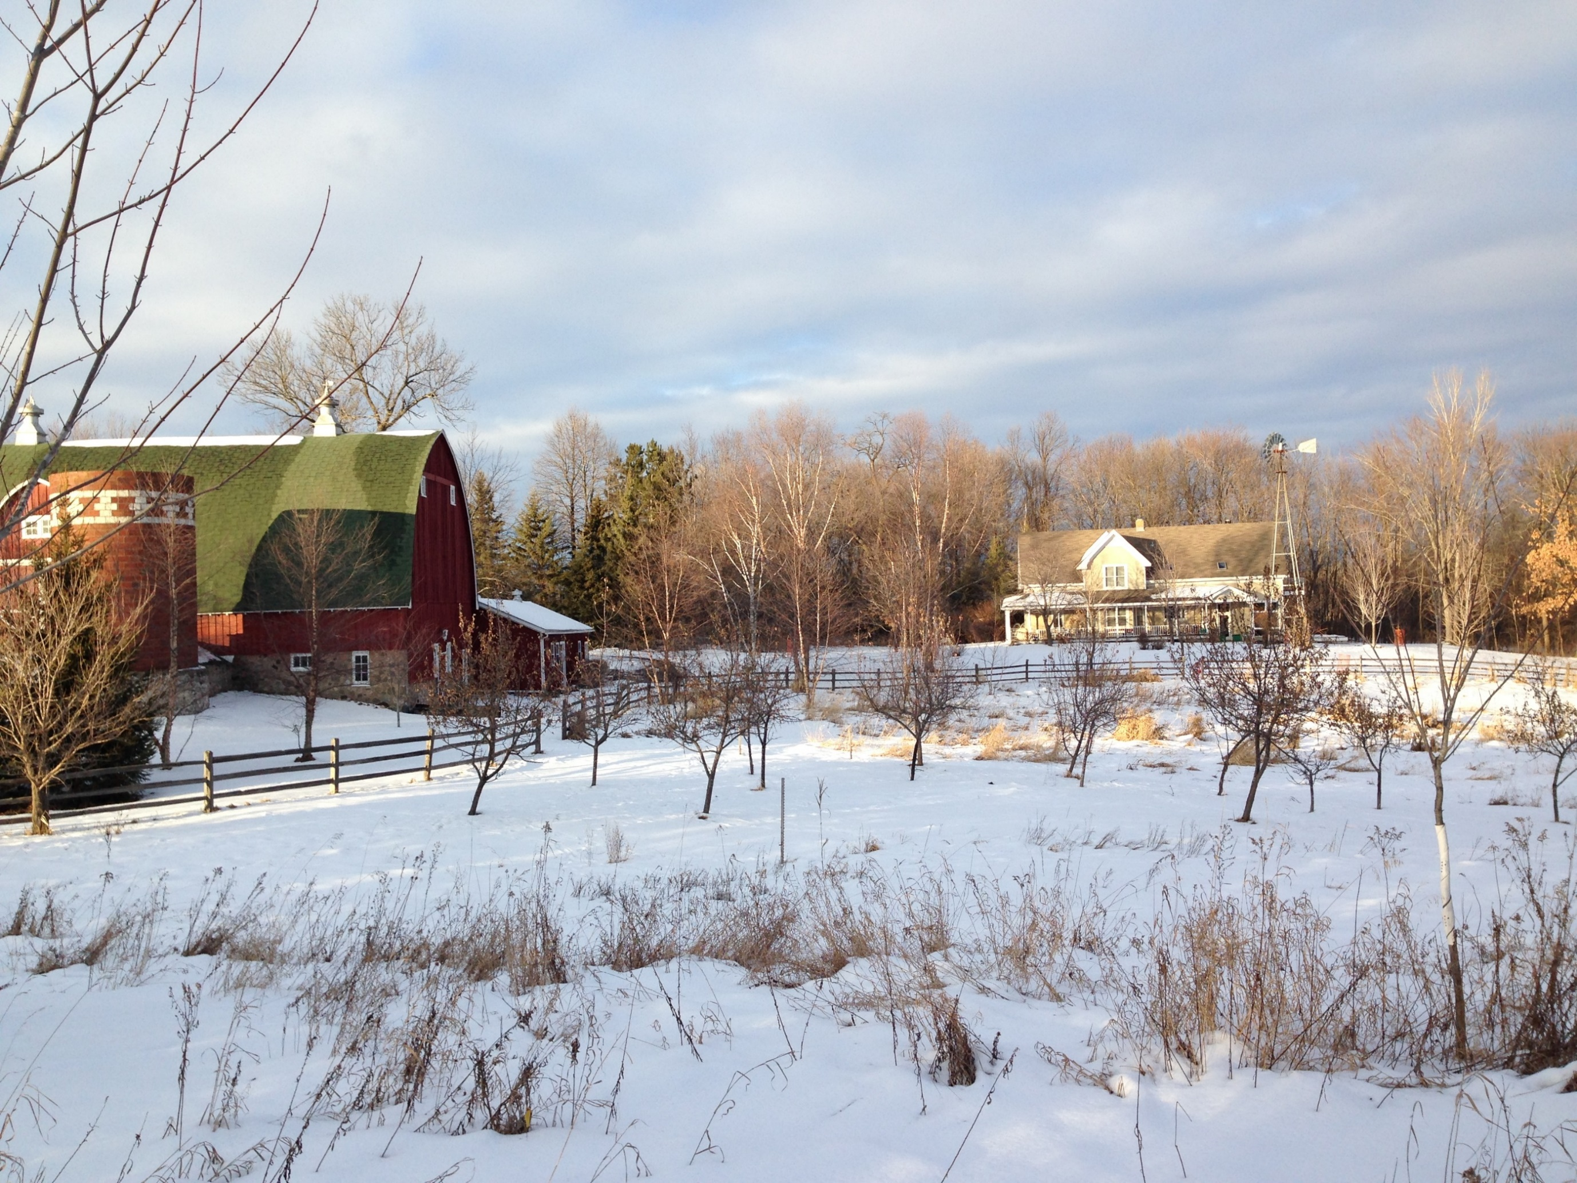**

* **Keep heat lamps and space heaters at least 3 feet from anything that can burn.**
* **Inspect heating equipment annually.**

* **Use extension cords on a limited and temporary basis.**
* **Clear dust and debris from lights and outlets.**
* **The barn is a smoke-free zone.**
* **When possible, store hay, straw and feed away from the main barn.**

PROTECT YOUR ANIMALS YOURYOURLIVELIVESTOCK

Did you know?

Over the past decade, two people and countless animals died in 625 livestock production and storage facilities costing over $56 million in damage.

Barns and agricultural buildings used for other things have additional code requirements.

Check with your local fire department for considerations unique to your farm.

**YOUR DEPARTMENT WEBSITE**

**Your department address Telephone: XXX-XXX-XXXX Fax: XXX-XXX-XXXX**