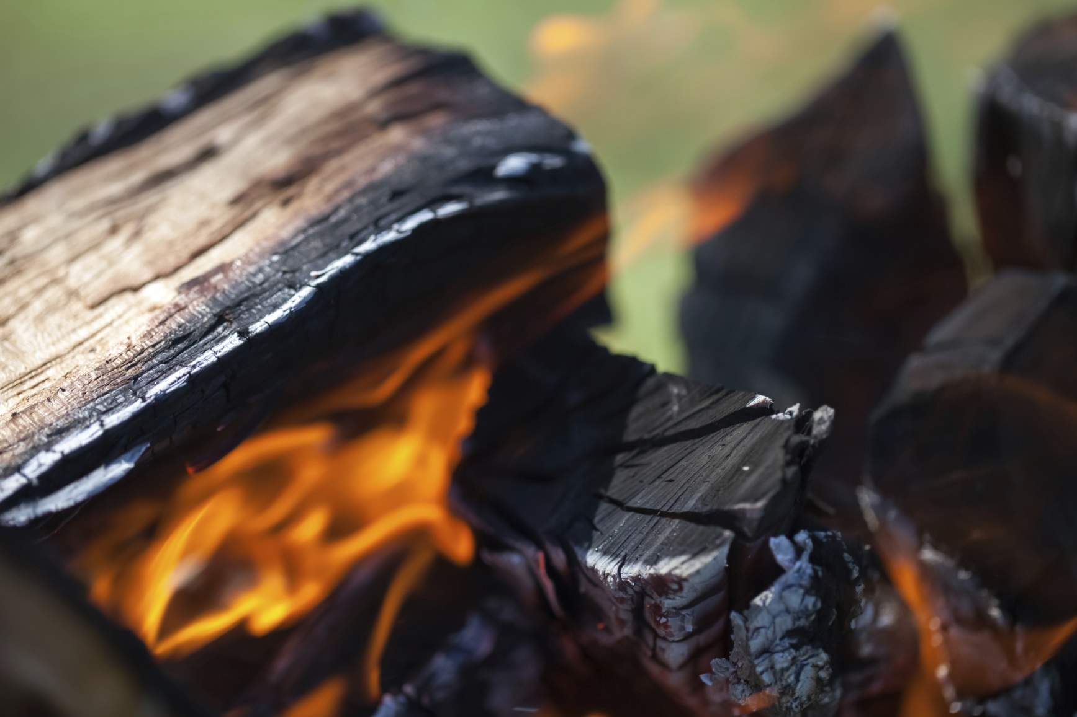

* **Use a fire ring and build your fire at least five feet away from any combustible material.**

* **Keep a bucket of water nearby to put out the fire.**
* **Keep a kid-free zone of three feet around the campfire.**
* **Never leave your campfire unattended.**
* **Check burning restrictions with the DNR before starting your campfire.**

Did you know?

Approximately 98 percent of wildfires in Minnesota are caused by humans.

Smokey Bear was created in 1944 and reminds us that “Only You Can Prevent Wildfires.”

More than 50 wildfires are started each year in Minnesota by campfires that are not completely extinguished, too large or unattended.

CAMPFIRE SAFETY

**YOUR DEPARTMENT WEBSITE**

**Your Department Address Telephone: XXX-XXX-XXXX Fax: XXX-XXX-XXXX**