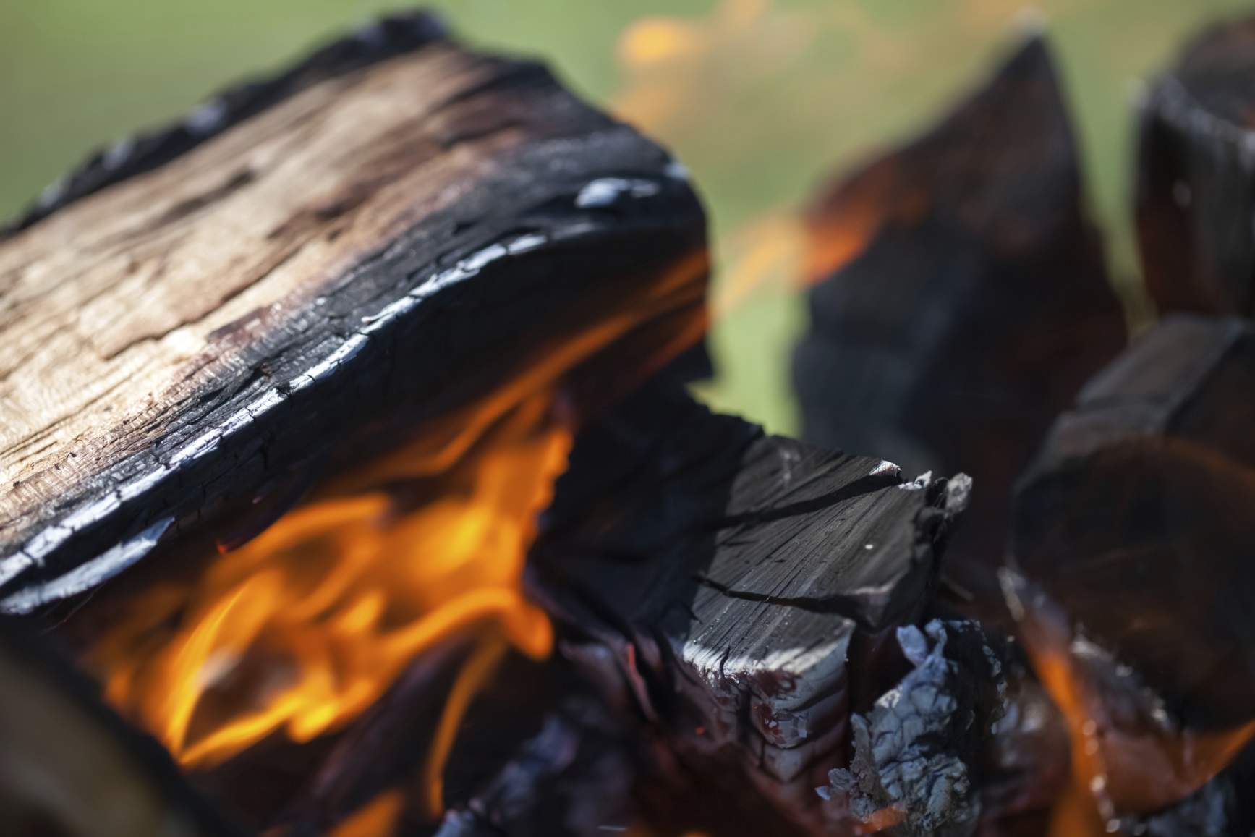

* **Siv ib lub qhov cub muaj ntug thaiv thiab rauv koj lub cub tawg kom deb tsib feet ntawm ib yam khoom twg uas yuav kub hnyiab tau.**

* **Tso ib lub thoob ntim dej nyob ze cia tua hluav taws.**
* **Cia qhov chaw tsis pub muaj me nyuam nyob ntawd kom deb peb feet ncig lub qhov cub rauv hauv hav zoov.**
* **Tsis yeem cia lub qhov cub rauv hauv hav zoov nws nyob nws tsis muaj tus saib.**
* **Xyuas txog cov cai txwv tsis pub rauv taws nrog DNR ua ntej pib koj lub qhov cub rauv hauv hav zoov.**

Koj puas paub?

Thaj tsam li ntawm 98 feem pua ntawm cov hluav taws kub tom hav zoov (wildfires) hauv Minnesota yog los ntawm tib neeg ua kub.

Tau tsim muaj Smokey Bear hauv xyoo 1944 thiab qhia rau peb kom nco ntsoov tias “Tsuas Yog Koj Nkaus Xwb Thiaj Li Tiv Thaiv Tau Kom Txhob Muaj Hluav Taws Kub Tom Hav Zoov.”

Muaj ntau tshaj ntawm 50 qhov hluav taws kub tom hav zoov txhua xyoo hauv Minnesota los ntawm cov qhov cub uas tsis muab tua kom tuag, rauv taws loj dhau los yog tsis muaj neeg nyob ntawd saib.

KEV KAJ HUV RAU LUB QHOV CUB RAUV HAUV HAV ZOOV

**YOUR DEPARTMENT WEBSITE**

**Your Department Address Xov tooj: XXX-XXX-XXXX Fax: XXX-XXX-XXXX**