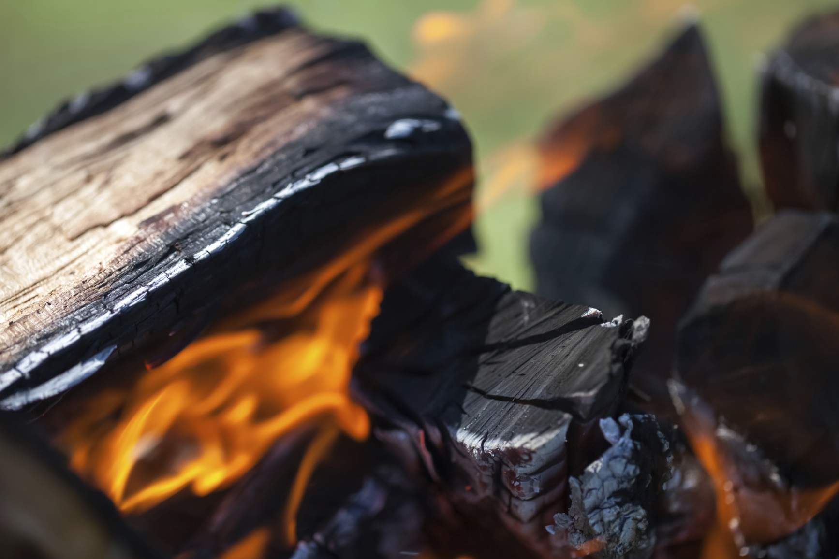

* **Isticmaal soohdimo wareegsan oo dabkaaga ku shido ugu yaraan shan fiit meel u jirta wax kasta oo guban kara.**

* **Hayso baaldi biyo ah oo kuu dhow si aad dabka ugu damiso.**
* **U samee aag caruurta ka caaggan oo ah illaa saddex fiit wareeg aha meesha dab shidasha.**
* **Weligaa ha ka tegin dabshidkaaga bilaa qof aad ka tagto.**
* **Ka hubi xaddidyada gubidda Waaxda Kheyraadka dabiiciga ah (DNR) kahor inta aadan bilaabin dab shidashada.**

Ma ogtahay?

Qiyaastii 98 boqolkiiba dababka ka kaca duurka Minnesota ayay dadku sababaan.

Smokey Bear waxaa la curiyay 1944 kii oo wuxuu ina xusuusiyaa“Kalidaa Ayaa Kortagi Kara Dabka Duurka.”

In ka badan 50 dabka duurka ka kaca ayay ku bilaabmeen dab shidashada dibadda ee aangrbi ahaanba la damin, aadka u wayn ama beylahsan sannad kasta gudaha Minnesota.

BADBAADADA DAB SHIDASHADA DIBADDA

**YOUR DEPARTMENT WEBSITE**

**Your department address Telefoonka: XXX-XXX-XXXX Faakis: XXX-XXX-XXXX**