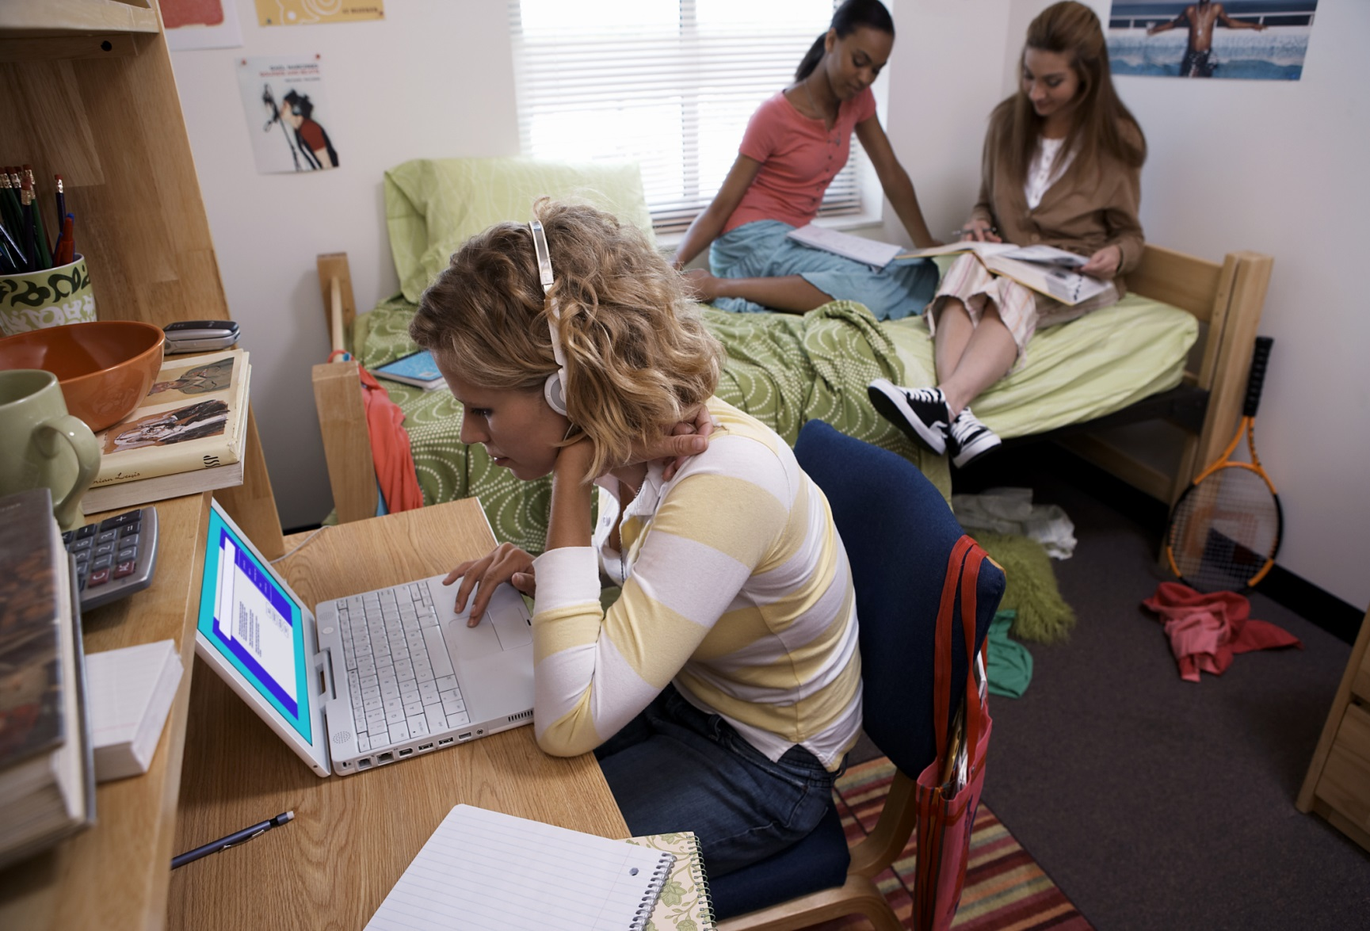

Koj puas paub?

Plaub ntawm tsib cov tsev kawm ntawv qib siab kub hnyiab ua rau muaj neeg tuag yog tshwm sim hauv cov tsev nyob tawm sab nraud ntawm lub tsev kawm ntawv, raws li Campus Firewatch tau hais.

Qhov ua rau tsev kawm ntawv kub hnyiab ntau tshaj yog ua noj, txhob txwm hlawv thiab haus luam yeeb tsis xyuam xim.

Cov tsev kawm ntawv kub hnyiab feem ntau yog thaum 5 mus rau 11 teev tsaus ntuj thiab thaum ob hnub so (weekends).

* **Siv cov tswm ciab tsis muaj nplaim taws los ua cov khoom kho kom zoo nkauj.**

* **Tsis txhob hais tias yuav tsis quav ntsej txog cov tswb nrov ceeb toom tsev kub hnyiab. Khiav tawm thiab tawm mus nyob sab nraud thaum cov tswb nrov.**
* **Muaj ib qho hom phiaj npaj khiav tawm uas muaj ob txoj kev tawm.**
* **Ua kom paub tseeb tias koj cov qhov rooj tawm thiab cov kev khiav tawm tsis muaj dab tsi thaiv; ua kom paub tseeb tias cov qhov rai/qhov rooj qheb tau yooj yim.**
* **Nyob nraim hauv chav ua noj thaum ua zaub ua mov noj; tsis yeem ua noj thaum koj nkees los yog qaug ib yam dab tsi.**

KEV KAJ HUV RAU KEV KUB HNYIAB HAUV TSEV KAWM NTAWV

**YOUR DEPARTMENT WEBSITE**

**Your department address Xov tooj: XXX-XXX-XXXX Fax: XXX-XXX-XXXX**