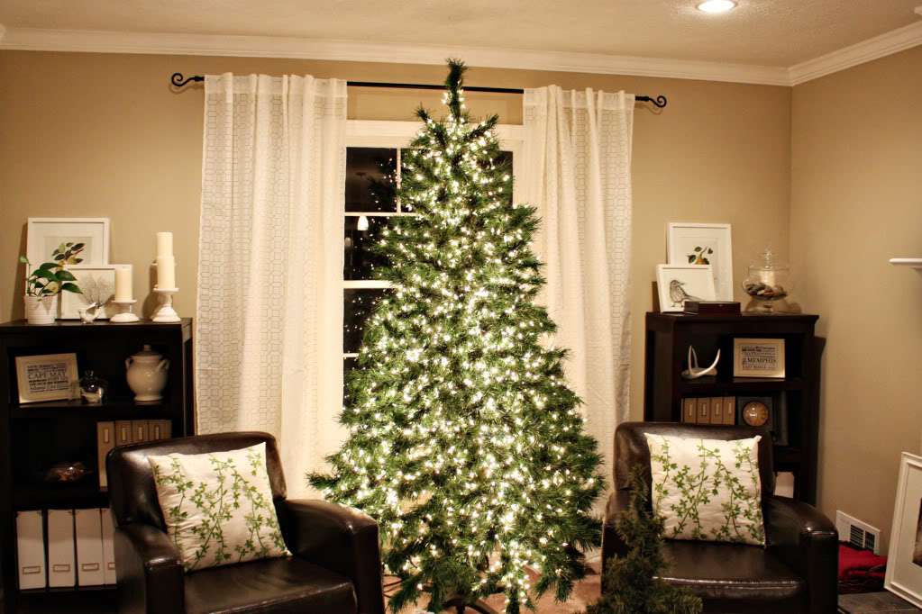

* **Never block an exit with a Christmas tree.**

* **Only use non-flammable decorations.**
* **Keep trees away from heat vents and other heat sources.**
* **Remove the tree from your home when the needles are brittle or begin to fall off.**
* **Pick a tree stand that can hold the tree securely. The stand should hold enough water for two days.**

CHRISTMAS TREE SAFETY

Did you know?

One of every three Christmas tree fires is caused by electrical problems.

You should throw out any holiday lights that show signs of fraying, bare wires or other wear.

If a home experiences a Christmas tree fire it is more likely to be fatal than other types of fires.

**YOUR DEPARTMENT WEBSITE**

**Your department address Telephone: XXX-XXX-XXXX Fax: XXX-XXX-XXXX**

