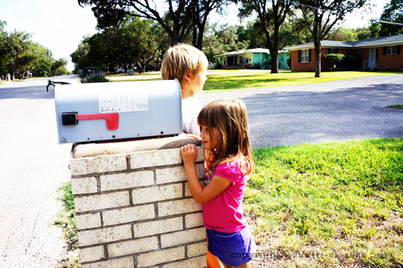

* **Designate a safe meeting place outside your home everyone can get to after a fire.**

* **Use graph paper to draw a floor plan of your home and show two ways out of each room.**
* **Make sure each family member is aware of escape options from each room.**
* **Practice your family escape plan twice each year.**
* **Walk through your home periodically and inspect all exits and escape routes.**

Did you know?

More than 80 percent of families have not practiced home fire drills.

Experts estimate you have as little as two minutes to safely escape your home once the smoke alarm sounds.

Working smoke alarms provide the valuable seconds needed to escape a burning residence.

ESCAPE PLANNING

**YOUR DEPARTMENT WEBSITE**

**Your Department Address Telephone: XXX-XXX-XXXX Fax: XXX-XXX-XXXX**