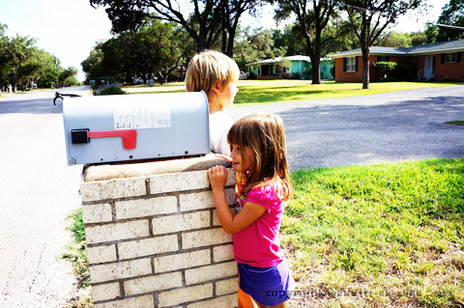

* **Teem ib qhov chaw sab nraum koj lub tsev kom sawv daws mus sib ntsib tom qab tsev kub hnyiab.**

* **Siv ib daim ntawv los kos ib daim duab hauv koj lub tsev thiab qhia ob txoj kev tawm ntawm txhua chav tsev.**
* **Ua kom paub tseeb tias txhua tus neeg hauv koj tsev neeg paub txog cov kev tawm ntawm txhua chav tsev.**
* **Sim koj tsev neeg lub hom phiaj npaj khiav tawm ob zaug txhua xyoo.**
* **Ncig mus kom thoob koj lub tsev tsis so thiab kuaj cov qhov rooj tawm thiab cov kev khiav tawm.**

Koj puas paub?

Ntau tshaj ntawm 80 feem pua ntawm cov tsev neeg tsis tau sim kom paub khiav tawm thaum muaj tsev kub hnyiab.

Cov kws paub zoo txog hluav taws hais tias koj muaj sij hawm tsawg kawg li ob feeb los mus khiav tawm ntawm koj lub tsev thaum lub tswb ceeb toom pa taws nrov.

Cov tswb nrov ceeb toom pa taws uas ua hauj lwm muab lub sij hawm txog fiab (seconds) uas muaj nqis los mus khiav tawm ntawm ib lub tsev kub hnyiab.

HOM PHIAJ NPAJ KHIAV TAWM

**YOUR DEPARTMENT WEBSITE**

**Your department address Xov tooj: XXX-XXX-XXXX Fax: XXX-XXX-XXXX**