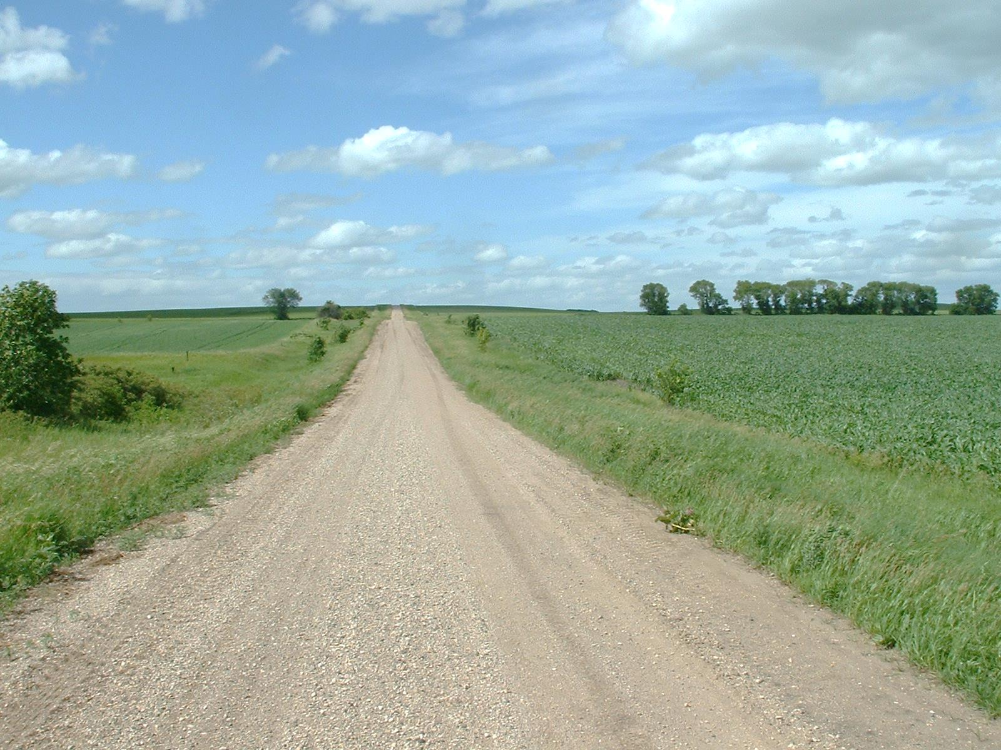

* **Be sure your address is visible to emergency vehicles.**

* **Learn first aid. Knowing a few basics will help you get started before first responders arrive.**
* **Be vigilant around outdoor fires.**
* **Store your firewood away from your home. If stored too close, it will make the flames spread quickly if there is a fire.**
* **Make sure your home is accessible for emergency vehicles.**

Did you know?

There is one structure fire every three minutes in rural Minnesota.

In 2013, fire caused more than $148 million in property damage in rural Minnesota.

Sixty-five percent of Minnesota’s fire loss happened in rural parts of the state.

RURAL AREA FIRE TIPS

**YOUR DEPARTMENT WEBSITE**

**Your department address Telephone: XXX-XXX-XXXX Fax: XXX-XXX-XXXX**