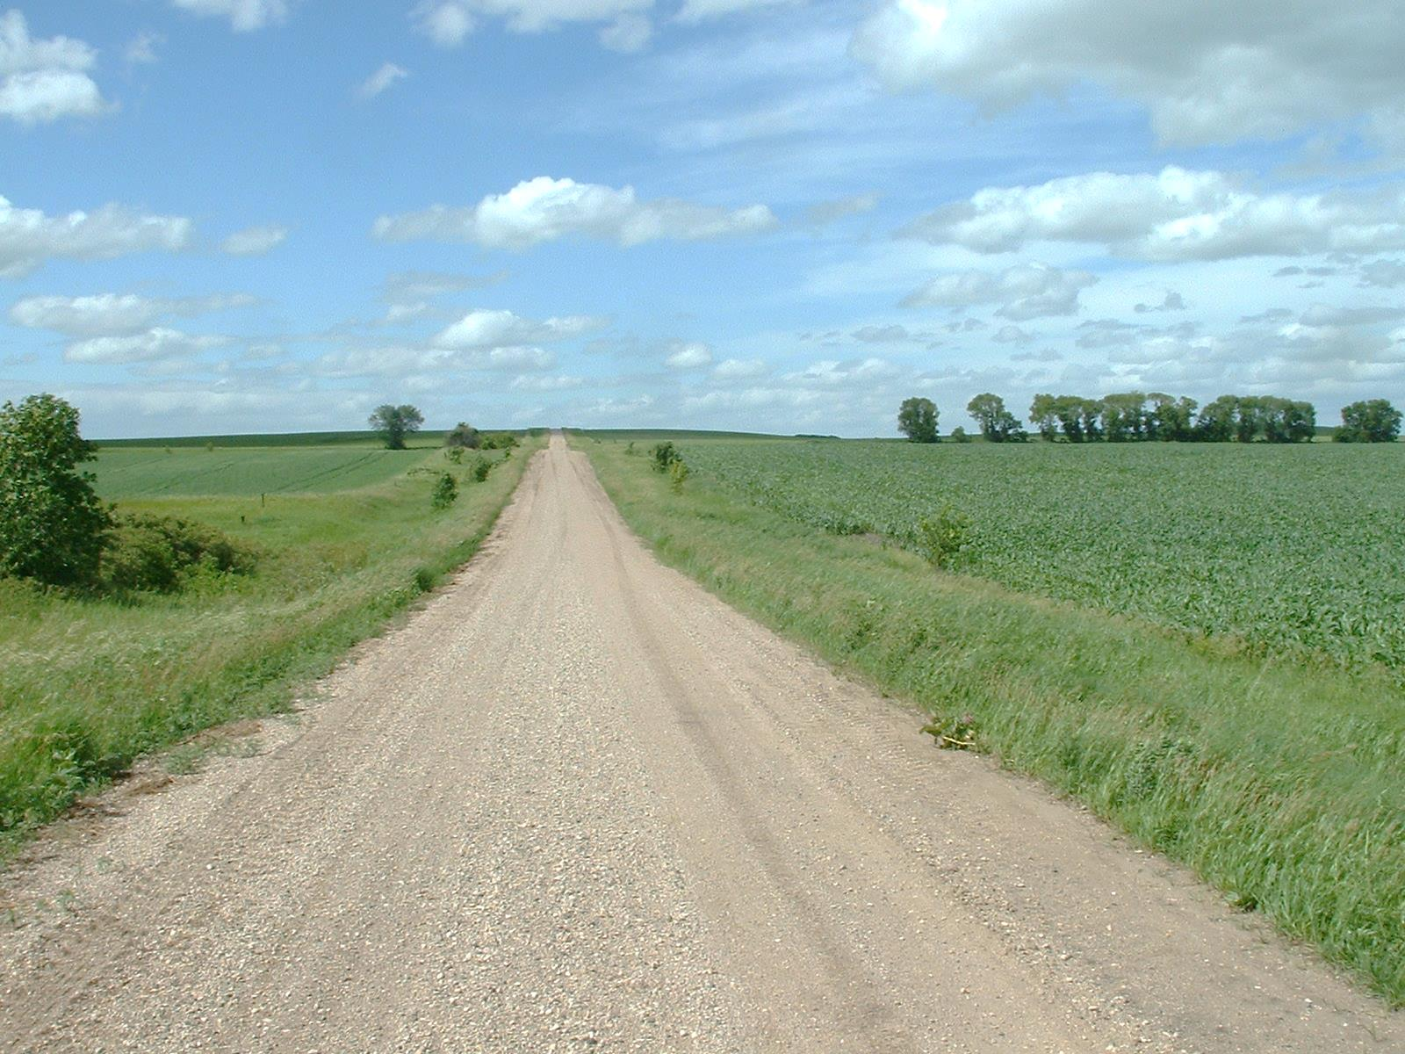

Koj puas paub?

Nws muaj ib lub tsev kub hnyiab txhua txhua peb feeb nyob tawm sab nraum nroog hauv Minnesota.

Hauv xyoo 2013, kev kub hnyiab ua rau tej khoom ntiag tug puas tsuaj ntaus tus nqi ntau tshaj $148 plhom (million) nyob tawm sab nraum nroog hauv Minnesota.

Rau caum-tsib feem pua ntawm Minnesota kev puas tsuaj los ntawm kub hnyiab yog muaj tshwm sim rau hauv cov thaj tsam nyob tawm sab nraum nroog ntawm lub xeev.

* **Yuav tsum ua kom koj qhov chaw nyob nrhiav pom yooj yim rau cov tsheb siv thaum muaj xwm ceev.**

* **Kawm kom paub tu qhov mob ua ntej. Kev paub yam puav yuav pab koj pib tu qhov mob ua ntej cov neeg muab kev pab tuaj txog.**
* **Ceev faj kom zoo thaum nyob ib ncig cov qhov cub rau taws sab nraum zoov.**
* **Muab koj cov taws rauv tso kom deb ntawm koj lub tsev. Yog muab tso ze dhau, yuav ua rau txais tau nplaim taws sai heev thaum muaj hluav taws kub hnyiab.**
* **Yuav tsum ua kom koj lub tsev muaj kev tuaj tau rau cov tsheb siv thaum muaj xwm ceev.**

LUS QHIA TXOG HLUAV TAWM KUB NYOB TAWM SAB NRAUM NROOG

**YOUR DEPARTMENT WEBSITE**

**Your department address Xov tooj: XXX-XXX-XXXX Fax: XXX-XXX-XXXX**