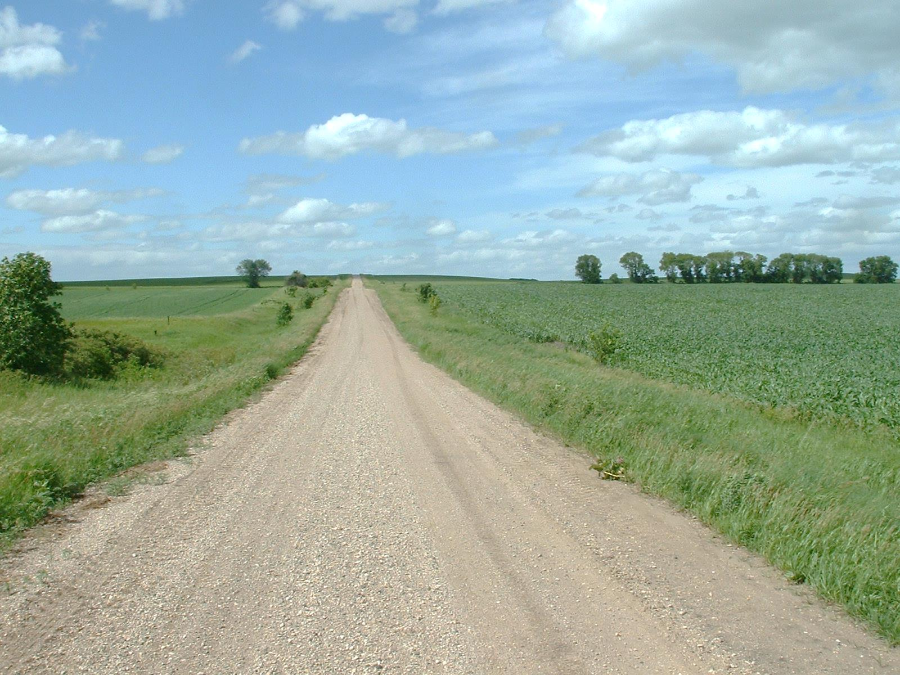

* **Hubi in cinwaankaaga laga arki karo gaadiidka gurmadka degdegga ah.**

* **Baro gargaarka degdegga ah. In aad ogaato waxayaabo dhowr oo aasaasi ah ayaa waxay kaa caawin doontaa inaad horayba aad wax uga qabato ka hor inta aysan iman kuwa gurmadka fidiya.**
* **Feejignaaw agagaarka dabka dibadda.**
* **Qoryaha dabka ku keydso gurigaaga meel ka duragsan. Haddii meel dhow lagu keydiyo, taas ayaa waxay u horseedi doonaan in si degdeg ah u faafa ololka haddii dab uu kaco.**
* **Hubi inuu gurigaagu leeyahay marin gaadiidka gurmadka ay si sahlan u gali karaan.**

Ma ogtahay?

Waxaa jira hal dab ka kaca dhisme saddex daqiiqaba miyiga Minnesota.

Gudihii 2013, dabka ayaa ku keenay khasaare ka badan $148 million hantida ku taal miyiga Minnesota.

Lixdan iyo shan boqolkiiba Minnesota ayay khasaaraha dabku ka dhaceen qaybo ka mid ah miyiga gobolka.

TALOOYINKA AAGGA DABKA MIYIGA

**YOUR DEPARTMENT WEBSITE**

**Your department address Telefoonka: XXX-XXX-XXXX Faakis: XXX-XXX-XXXX**