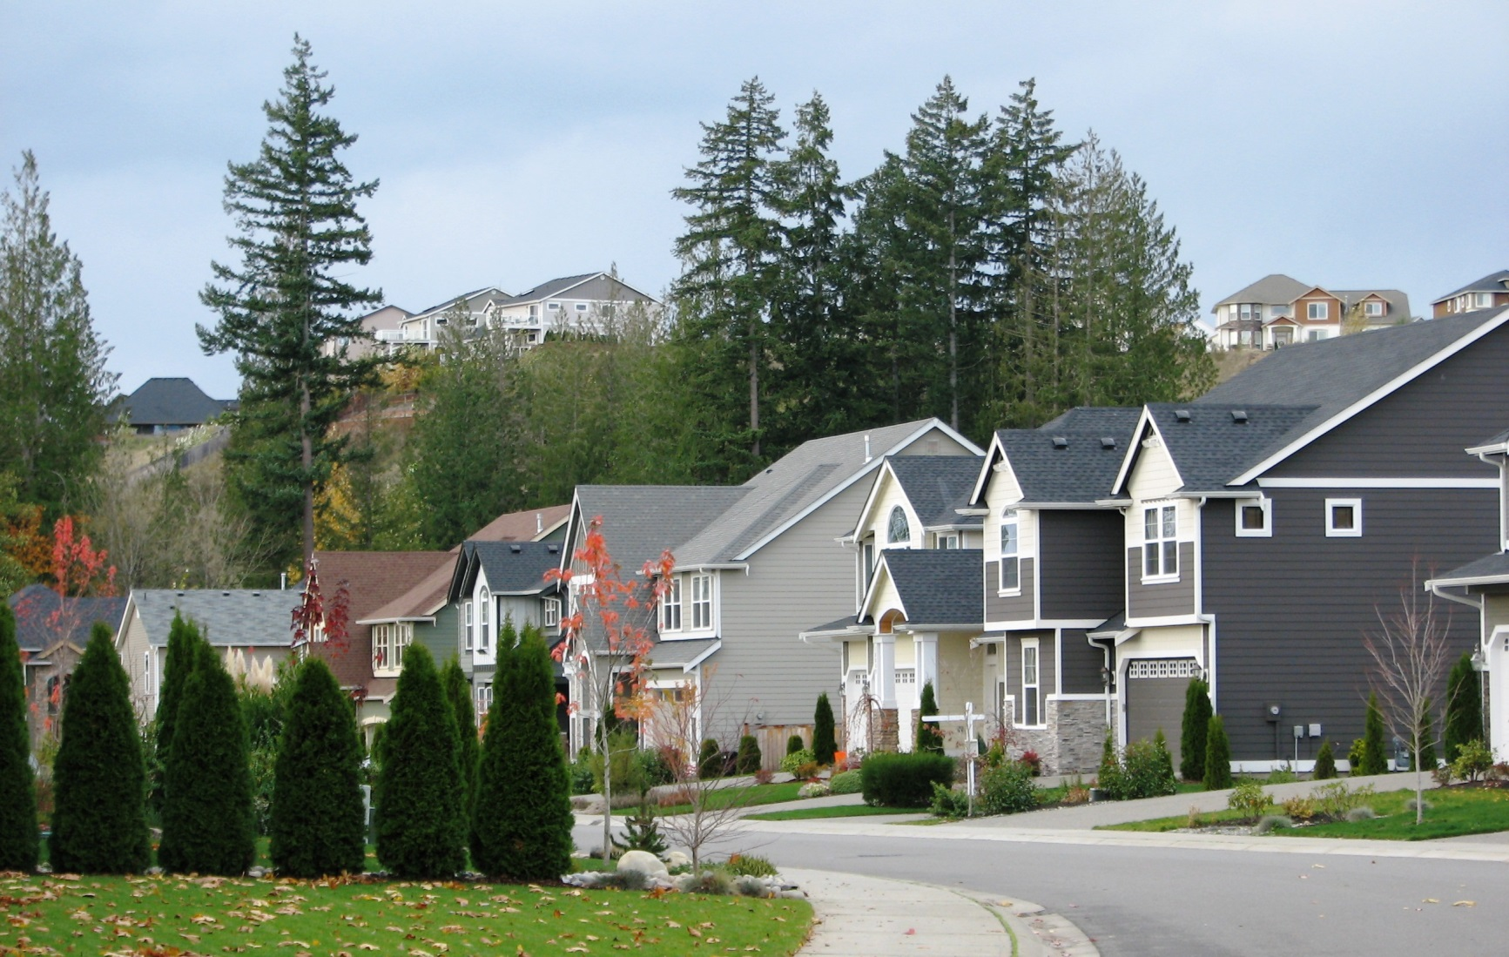

* **Saib chav ua noj kom zoo. Yog koj tawm ntawm chav ua noj mus, muab lub qhov cub tua.**

* **Ceev txhua yam uas yuav txais tau hluav taws kom deb tsawg kawg peb feet ntawm cov tshuab ua kom tsev sov (space heaters), cov qhov cub rauv taws los yog cov chaw rauv taws.**
* **Sim siv koj tsev neeg lub hom phiaj npaj khiav tawm thiab yuav tsum ua kom txhua tus paub tias yuav mus sib ntsib qhov twg thaum tsev kub hnyiab.**
* **Muaj cov tswb ceeb toom pa taws uas ua hauj lwm rau hauv koj lub tsev. Sim seb puas ua hauj lwm txhua hli; hloov cov roj teeb ib xyoos ob zaug.**
* **Ceev cov tswm ciab kom deb ntawm tej khoom uas txais tau hluav taws zoo thiab tsis yeem cia tswm ciab nws taws nws tsis muaj tus saib.**

Koj puas paub?

Minnesota cov tsev tua hluav taws tau teb rau ntau tshaj ntawm 250,000 tsab xov tooj hu tias muaj xwm ceev xyoo tas los.

Minnesotans tau poob txog $229 phlom (million) rau cov kev piam sij vim hluav taws kub hauv xyoo 2013.

Cov kws paub zoo txog hluav taws hais tias cov tsev neeg yuav muaj sij hawm tsawg kawg li ob mus rau peb feeb rau lawv khiav tawm thaum tsev kub hnyiab.

NYOB KAJ HUV TSIS KUB HLUAV TAWS

**YOUR DEPARTMENT WEBSITE**

**Your department address Xov tooj: XXX-XXX-XXXX Fax: XXX-XXX-XXXX**