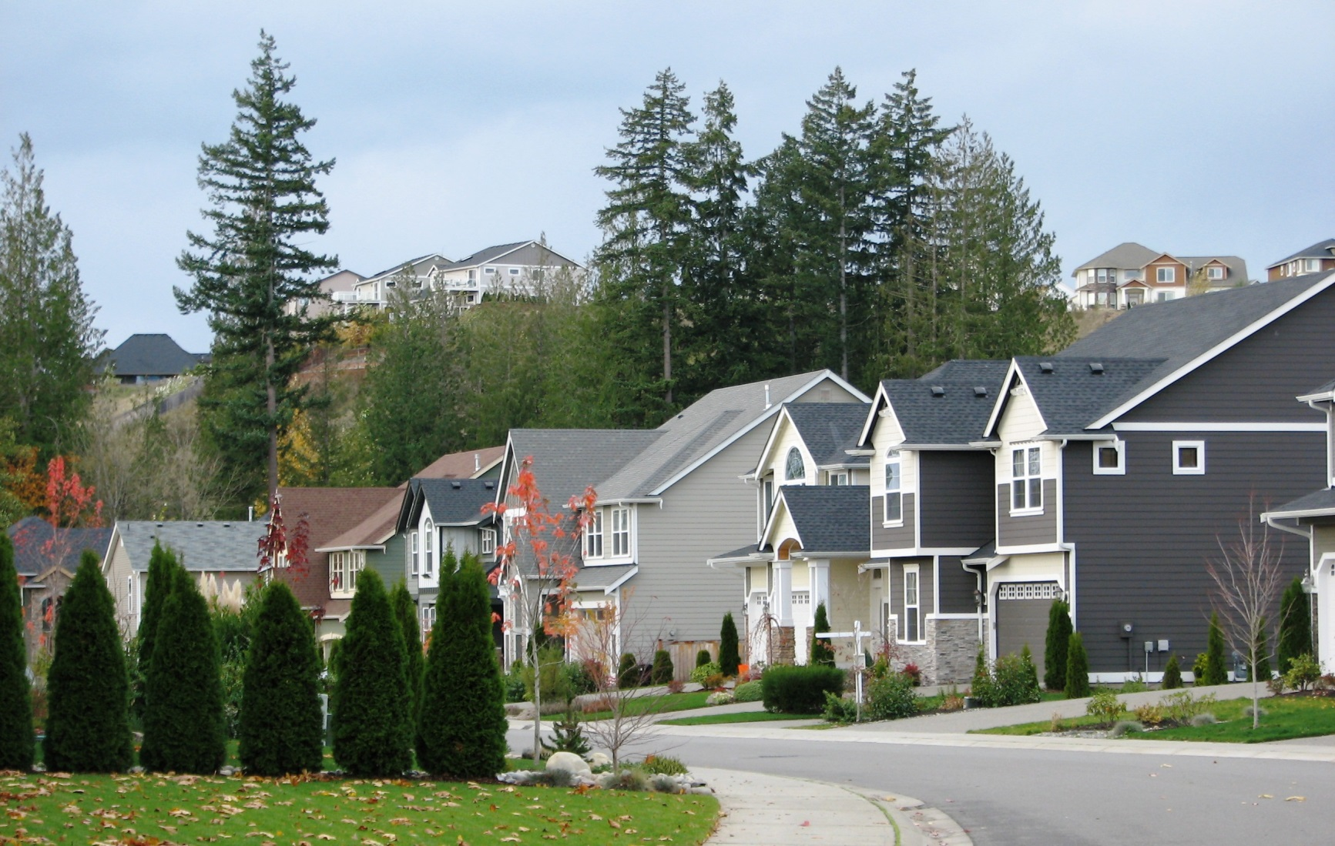

Ma ogtahay?

Waaxyada dab-demiska Minnesota sannadkii tagay u gurmaday in ka badan 250,000 oo wicitaanno xaalado degdegga ahaa.

Sannadkii 2013 reer Minnesota khasaaraha dabka ka soo gaaray ayaa gaaraya $229 milyan.

Qabiirada dabka ayaa ku warbixiya inay qoysasku haystaan in yar ka sida laba illaa saddex daqiiqo si ay uga baxsadaan dabka guriga.

* **Dareen taxadar leh jikada sii. Haddii jikada aad ka tagayso, dami cunto kariyaha (istoofka).**

* **Ka fogee wax kasta oo guban kara ugu yaraan saddex fiit meel kulayliyeyaashaya, cunto kariyaha qoryaha ama goobta-dabka.**
* **Ku tababbarta qorshahiina baxsiga ee qoyska oo hubiya meesha qof kasta ay ku kulmayaan kaddib dab kaca.**
* **Digniin bixiyaha qiiqa ee guriaaga ha noqdo kuwa shaqeeya. Bil kasta tijaabi; sannadkiiba laba jeer baatariyada beddel.**
* **Ka fogee shamacyada waxyaabaha guban kara oo waligaa ha kaga tegin shamacyada cid la'aan.**

KA BADBAAD DABKA

**YOUR DEPARTMENT WEBSITE**

**Your department address Telefoonka: XXX-XXX-XXXX Faakis: XXX-XXX-XXXX**