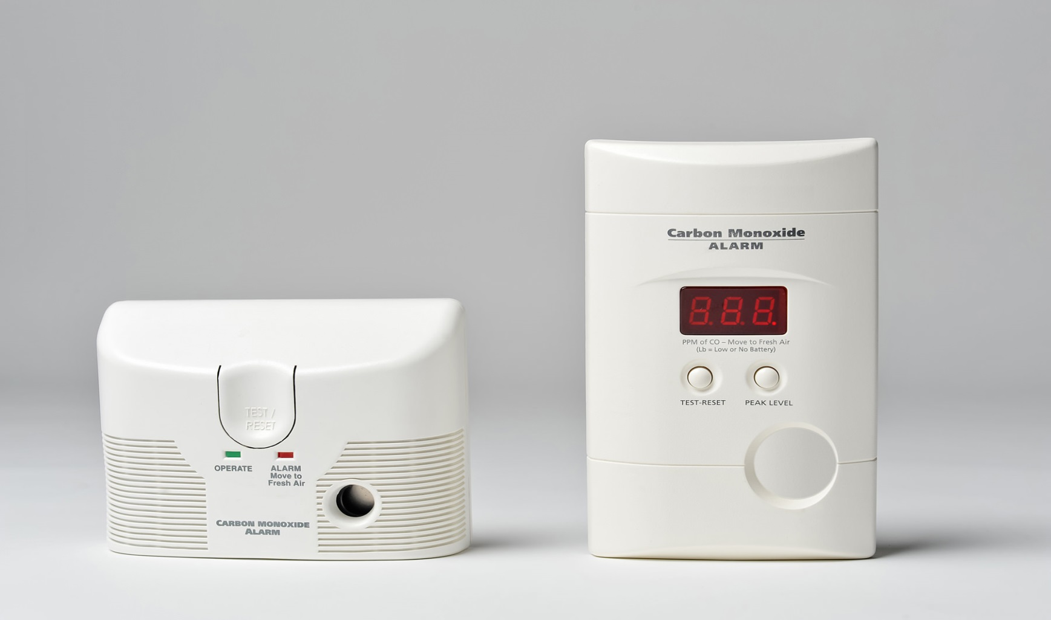

YAM UAS KOJ YUAV TAU PAUB HAIS TXOG:   
COV TSWB NROV CEEB TOOM CO

* **Yuav tsum muab cov tswb nrov ceeb toom txog carbon monoxide teeb deb li 10 feet ntawm txhua chav pw los yog teeb rau sab hauv txhua chav pw.**

* **Sim cov tswb nrov ceeb toom CO txhua hli.**
* **Yog ib lub tswb ceeb toom CO nrov thiab zoo li koj tsis xis neej, hu rau 911 tam sid. Yog koj tsis ua li cas, qhib cov qhov rai thiab qhov rooj thiab hu rau koj lub tuam txhab tso cua sov.**
* **Tu kom tsis muaj snow thiab tej khoom sw ntawm lub qhov cub rhaub cua sov (furnace), qhov cub rauv taws los yog qhov cub ua noj cov qhov cua tawm nyob ncig koj lub tsev los mus tiv thaiv kom txhob muaj CO ntau tuaj.**

Koj puas paub?

Carbon monoxide yog ib hom roj (gas) uas tsis hnov tsw, tsis hnov tias qab li cas thiab tsis pom.

Cov cim uas neeg raug lom los ntawm CO yog mob taub hau, xeev siab, nkees, ntuav thiab tsis meej pem.

Cov chaw ua noj thiab ua kom tsev sov uas siv roj (fuel) thiab tsis muaj cua khiav mus los tau los yog tsis ua hauj lwm zoo yuav ua tau rau muaj CO hauv lub tsev.

**YOUR DEPARTMENT WEBSITE**

**Your department address Xov tooj: XXX-XXX-XXXX Fax: XXX-XXX-XXXX**