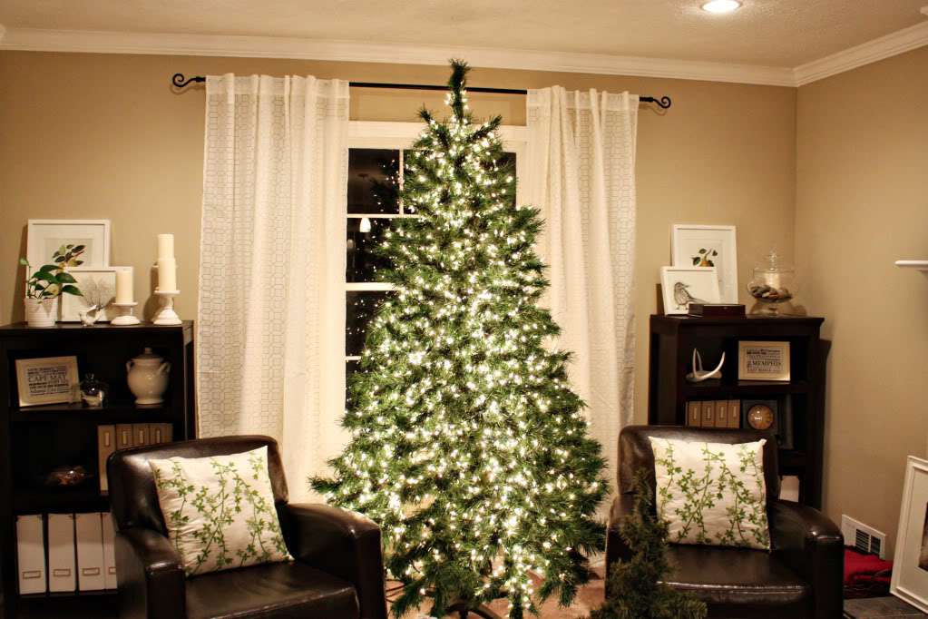

BADBAADADA GEEDKA KIRISMASKA

* **Marinka laga baxo marnaba ha ku dadbin geedka kirismaska.**

* **Isticmaal waxyaabaha qurxinta ee aan guban kaliya.**
* **Geedaha ka fogee marinnada kulaylka iyo ilaha kale oo kulaylka.**
* **Geedka gurigaaga ka saar markay qodaxdoodu jajab ku dhaw yihiin ee ay bilaabaan inay soo dhacaan.**
* **Dooro sheey geedka si ammaan ah loo saari karo ama hayn kara. Waa in biyo laba maalmood ku filan inuu ku jiraa sheeyga la saarayo.**

Ma ogtahay?

Midkood saddexda dab ee ka kaca geedka Kirisimaska ayaa ka yimaad sabab koronto.

Waa inaad iska tuurtaa kasta nalalka ciidaha ee lagu arko calaamadaha sariigga, fiilooyin qaawan ama duugow kale.

Haddii guriga uu qabsado dab uu sababay geed Kirismas waxay u badan tahay in halis ay ka timaado marka loo eego noocaca kale ee dabka.

**YOUR DEPARTMENT WEBSITE**

**Your department address Telefoonka: XXX-XXX-XXXX Faakis: XXX-XXX-XXXX**

