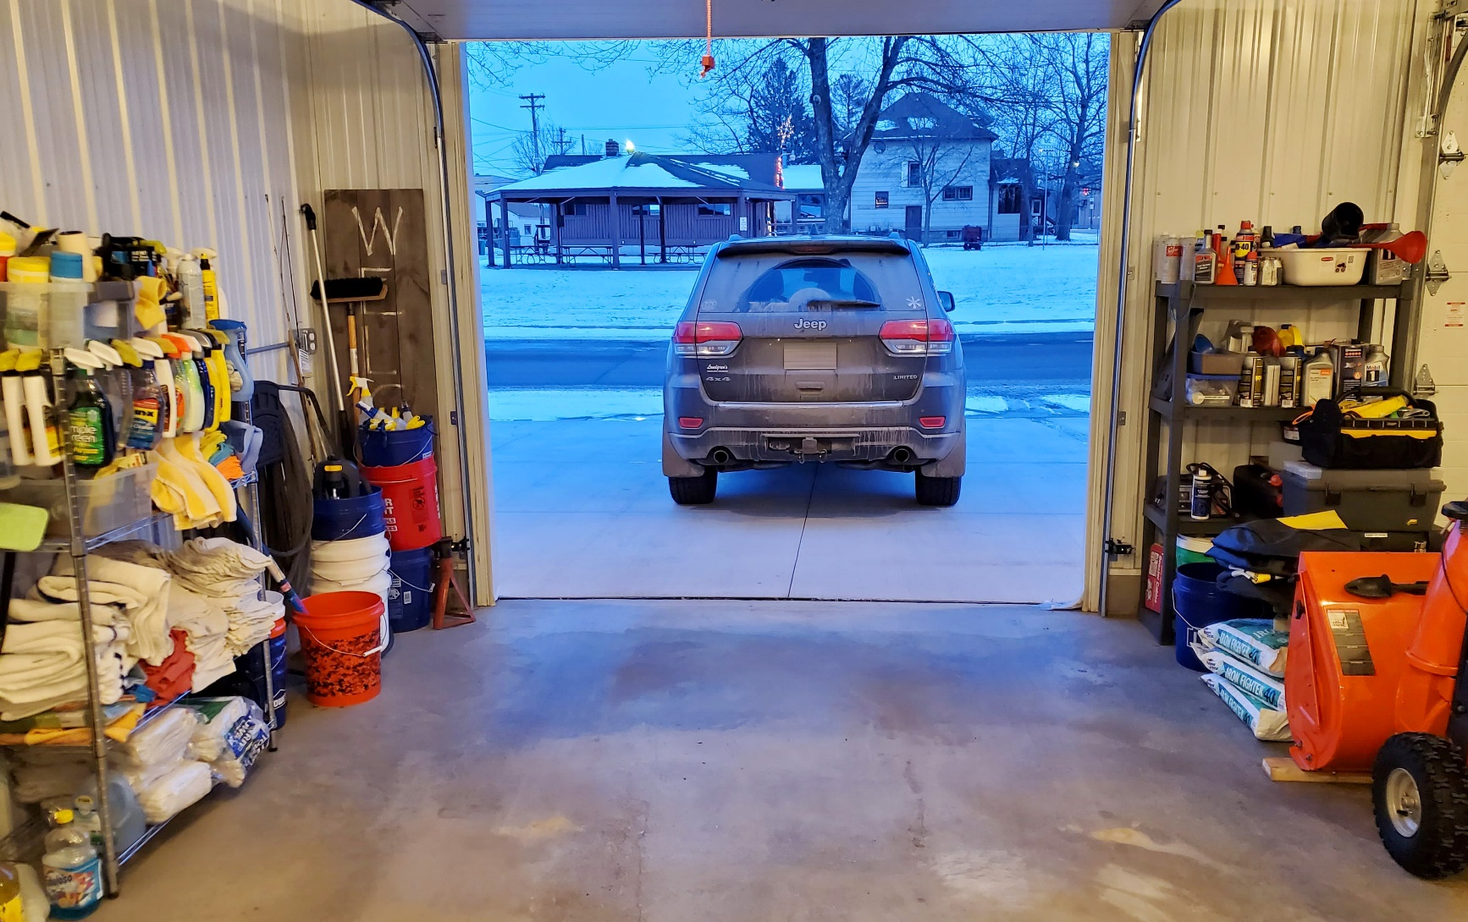



Did you know?

You should not use an extension cord when charging an appliance or tool. Plug the charger directly into an outlet.

Oil- and stain-soaked rags can spontaneously combust if improperly stored. Hang rags outside until they are fully dried. Do not throw soaked rags into a pile until they are completely dry.

* **Working on a project involving oil, gasoline, paints, propane or other flammable materials? Make sure there is proper ventilation.**
* **Store flammable liquids in labeled containers – and only in small amounts. Keep the containers away from heaters, appliances, pilot lights and other sources of heat or flame.**

* **Charging a tool? Only plug one charging tool into an outlet at a time. Unplug the tool and charger when not in use.**

GARAGE FIRE SAFETY

**YOUR DEPARTMENT WEBSITE**

**Your department address Telephone: XXX-XXX-XXXX Social media:**