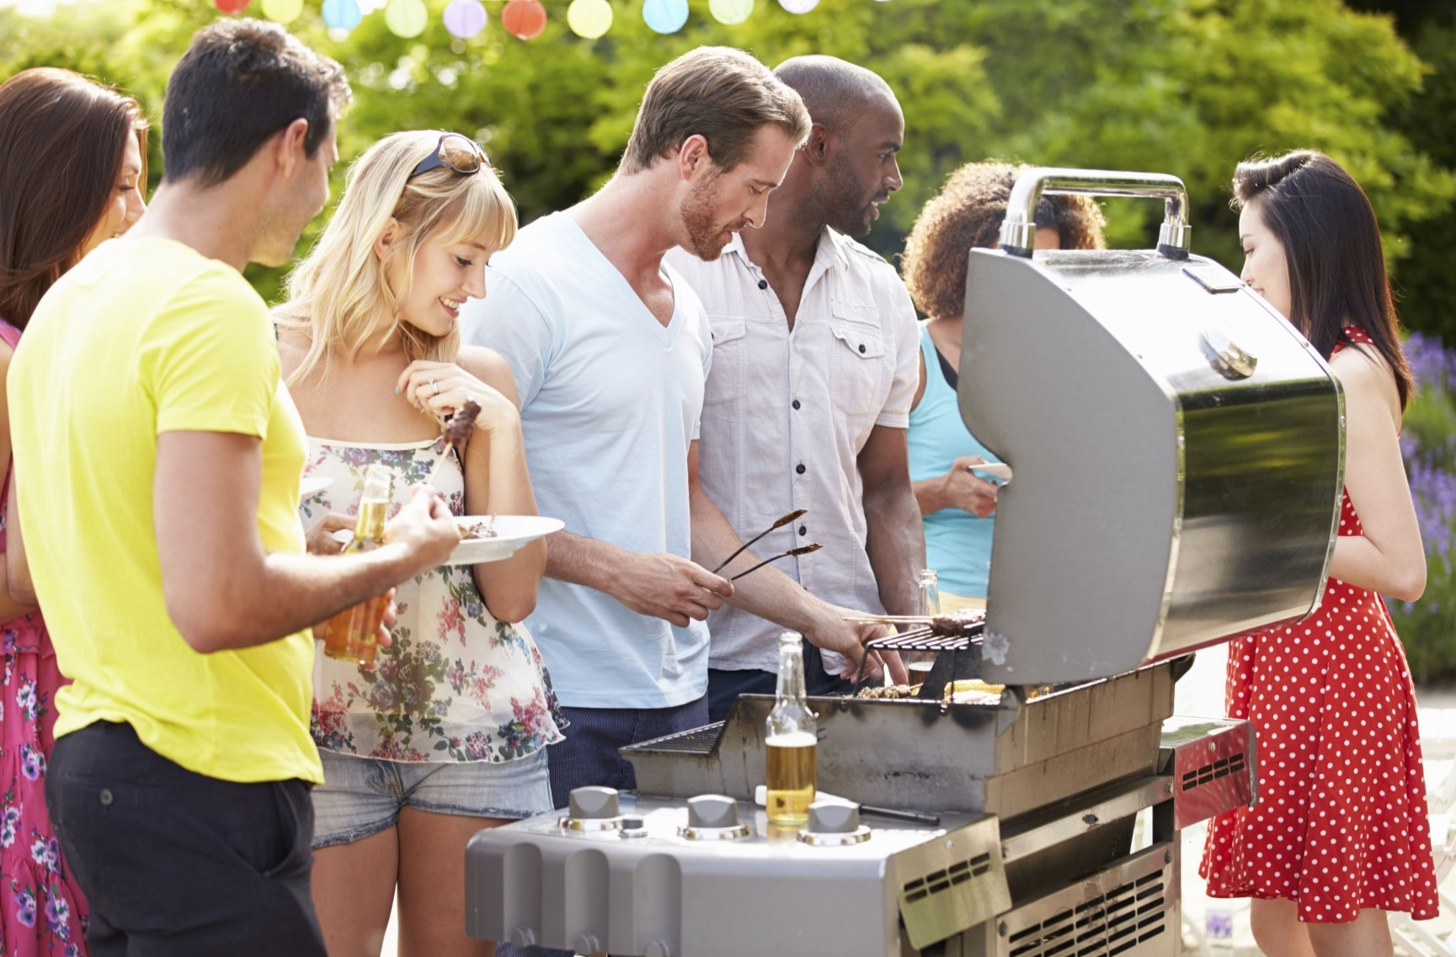

Ma ogtahay?

Julaay waa bisha ugu badan dabka ka kaca guryaha Maraykanka.

Dababka girgiraha wax soliddaayaa ku bilaama intooda badan iyaga oo waxyaaba guban kara aad ay ugu dhow yihiin girgiraha.

Intooda badan dabka guriga ee ku lug leh girgirayasha wax sola bilaabaan girgirayaasha gaasta, ee ma aha kuwa dhuxusha.

Waa inaad ka eegto daroorin dhuunta haanta gaasta ee ku yaal girgirayaasha buroobeynka kahor intaadan isticmaalin marka ugu horeysa.

* **Guriga dhexdiisa marnaba cunto haku solin [grill] oo ha beylihin.**

* **Markaad hurinayso girgiraha solitaanka, korku ha u furnaado. Haddii u huri waayo dhawrka ugu horreeya ka dib, sug illaa shan daqiiqo kahor intaadan isku dayin mar kale.**
* **Tubooyinka iyo dhuumaha iska hubi kahor inta aadan isticmaalin girgiraha solitaanka aan la isticmaalin in muddo ah.**
* **Gigirahaaga solidda nadiifi.**
* **Markaad cunto ku solayso girgiraha, dhig girgiraha meel ka fog gurigaaga, deyrka bersadda iyo ka soo hooseysa saqafyada barandada.**

BADBAADADA SOLLITAANKA GIRGIRHA

**YOUR DEPARTMENT WEBSITE**

**Your department address Telefoonka: XXX-XXX-XXXX Faakis: XXX-XXX-XXXX**