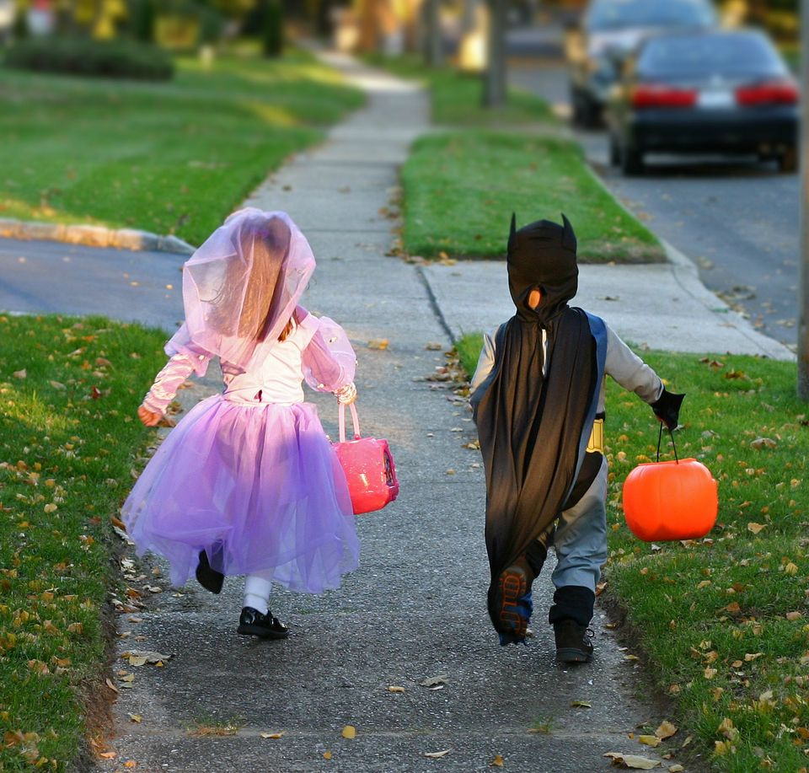

BADBAADADA HALAWIINTA

* **Iska ilaali dharka gaarka ah ee marada dheer ama ama dharka babbanaya ah — waxay noqon karaan halis dab ah.**
* **Isticmaal shamacyada baatariga ku shaqeeya ama qoryo ka dhex ifa jack-o-lantern.**
* **Bar carruurtaada inay ka fogaadaan ololka bannaan oo haddii dharkooda dab qabsado inay istaagaan, oo dhulka intay jiifsadaan isrogrogaan.**
* **Ku hay waxyaabaha qurxinta sida cawsa engegen iyo caleemaha geeda hadhuudhka wixii kasta ee ilo dab ah.**

Ma ogtahay?

1/3 oo ah waalidiinta kaliya ay carruuttooda ay kala hadlaan arrimaha ku saabsan nabadgelyada Halawiinta (Halloween) sannad kasta.

In u dhiganta laba jeer ayay dilaan baabuurtu carruurtu markay lugaynayaan Hawalawiinta marka loo eego maalin kasta oo sannadka inta kale ka mid ah.

Dababka shakiga laga qobo iyo dab kicinta dembiga ah ayaa samada isku shareera wakhtiyada Halawiinta.

**FIRE DEPARTMENT WEBSITE**

**Your fire department street address FIRE DEPARTMENT PHONE FIRE DEPARTMENT FAX**