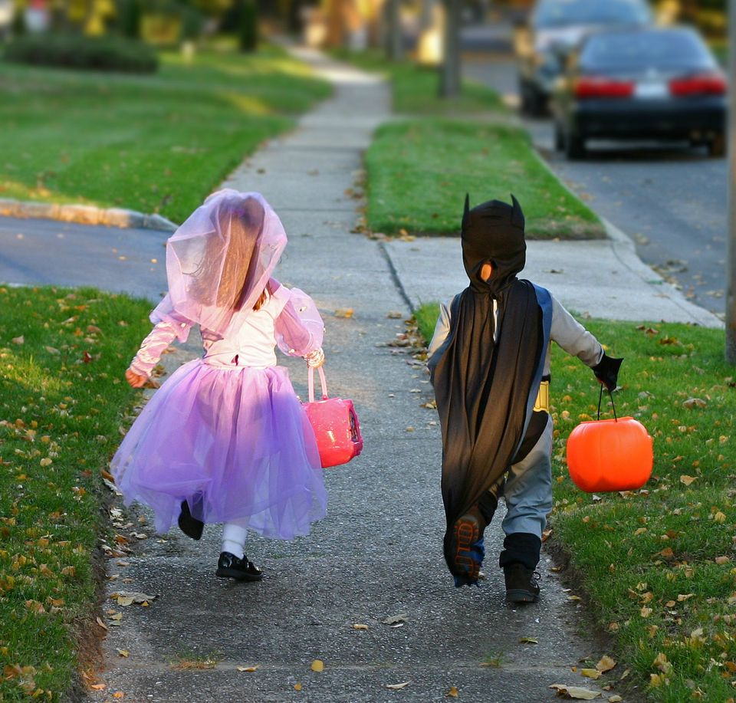

Did you know?

Only 1/3 of parents talk to their kids each year about Halloween safety.

Twice as many kids are killed as pedestrians by cars on Halloween than on any other day of the year.

Suspicious fires and arson fires skyrocket around Halloween.

HALLOWEEN SAFETY

* **Avoid costumes with long or billowing fabric — it can be a fire hazard.**
* **Use battery operated candles or glow sticks inside jack-o-lanterns.**
* **Teach children to stay away from open flames and to stop, drop and roll if their clothes catch fire.**
* **Keep decorations like hay and corn stalks away from any ignition source.**

**FIRE DEPARTMENT WEBSITE**

**Your fire department street address FIRE DEPARTMENT PHONE FIRE DEPARTMENT FAX**