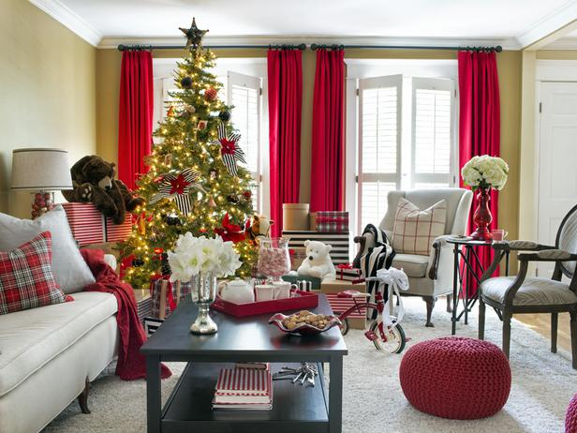

* **Use flameless candles when decorating for the holidays.**

* **Make sure exit paths and exits are clear of holiday decorations and clutter.**
* **Cooking for a holiday gathering? Never leave food cooking on the stove unattended.**
* **Keep a timer with you when baking in the oven so you don’t lose track of time; check on items in the oven frequently.**

WINTER HOLIDAY SAFETY

Did you know?

Two of every five home decoration fires are started by candles.

The three leading causes of Minnesota fires are all holiday staples: Cooking, heating and open flames.

Nearly half of holiday decoration fires happen because decorations are placed too close to a heat source.

**YOUR DEPARTMENT WEBSITE**

**Your Department Street Address Telephone: XXX-XXX-XXXX Fax: XXX-XXX-XXXX**