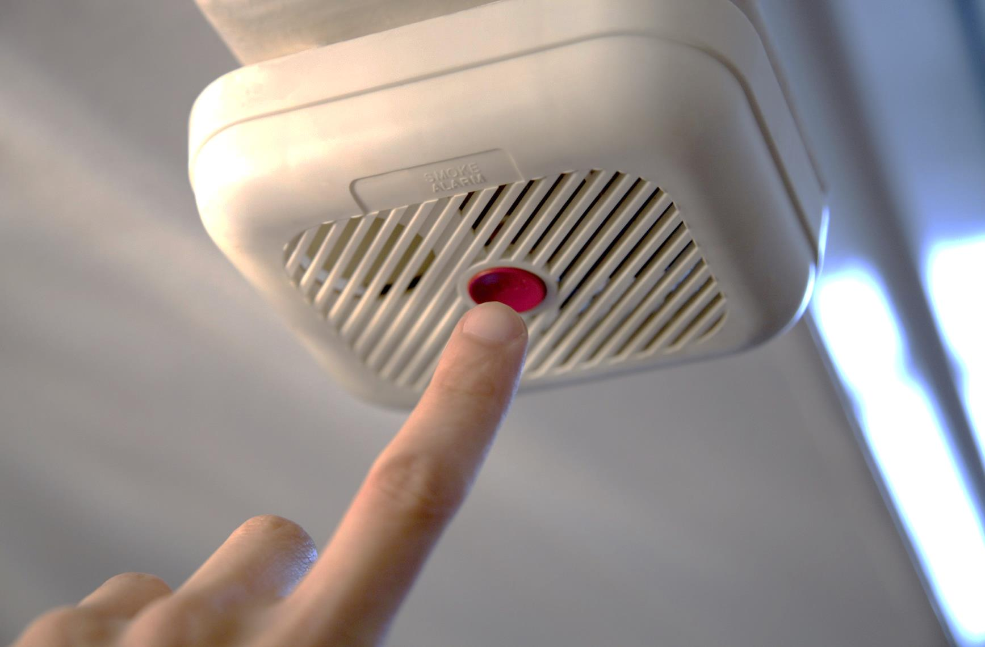

* **Teeb cov tswb nrov ceeb toom pa taws rau hauv txhua chav pw, sab nraud ntawm txhua qhov chaw pw thiab ntawm txhua theem ntawm lub tsev, nrog rau hauv qab daus.**

* **Muab cov tswb nrov ceeb toom pa taws hauv koj lub tsev cab kom sib txuas. Li no, thaum ib lub nrov, ces txhua lub nrov.**
* **Qhia cov me nyuam kom paub lub suab nrov thiab kom khiav tawm ntawm lub tsev mus thaum hnov lub suab nrov.**
* **Tso cov tswb nrov rau ntawm lub qab nthab kom deb li ntawm plaub inches ntawm daim phab ntsa: cov tswb nrov uas muab tso rau ntawm daim phab ntsa yuav tsum deb plaub mus rau 12 inches hauv qab ntawm qab nthab.**

DAB TSI UAS KOJ YUAV TAU PAUB TXOG:   
COV TSWB NROV CEEB TOOM PA TAWS

Koj puas paub?

Yuav tsum muab cov tswb nrov ceeb toom pa taws sim txhua hli.

Yuav tsum muab cov roj teeb hloov tsawg kawg ib xyoos ib zaug.

Yuav tsum muab tag nrho cov tswb nrov ceeb toom pa taws hloov rau cov tshiab txhua txhua 10 lub xyoo.

Cov tswb nrov ceeb toom pa taws uas ua hauj lwm yuav txiav tau txog ib nrab ntawm txoj kev yuav tuag tau los ntawm tsev kub hnyiab.

**sfm.dps.mn.gov**

**445 Minnesota St., Suite 145, St. Paul, MN 55101 Xov tooj: 651-201-7200 Fax: 651-215-0525**

