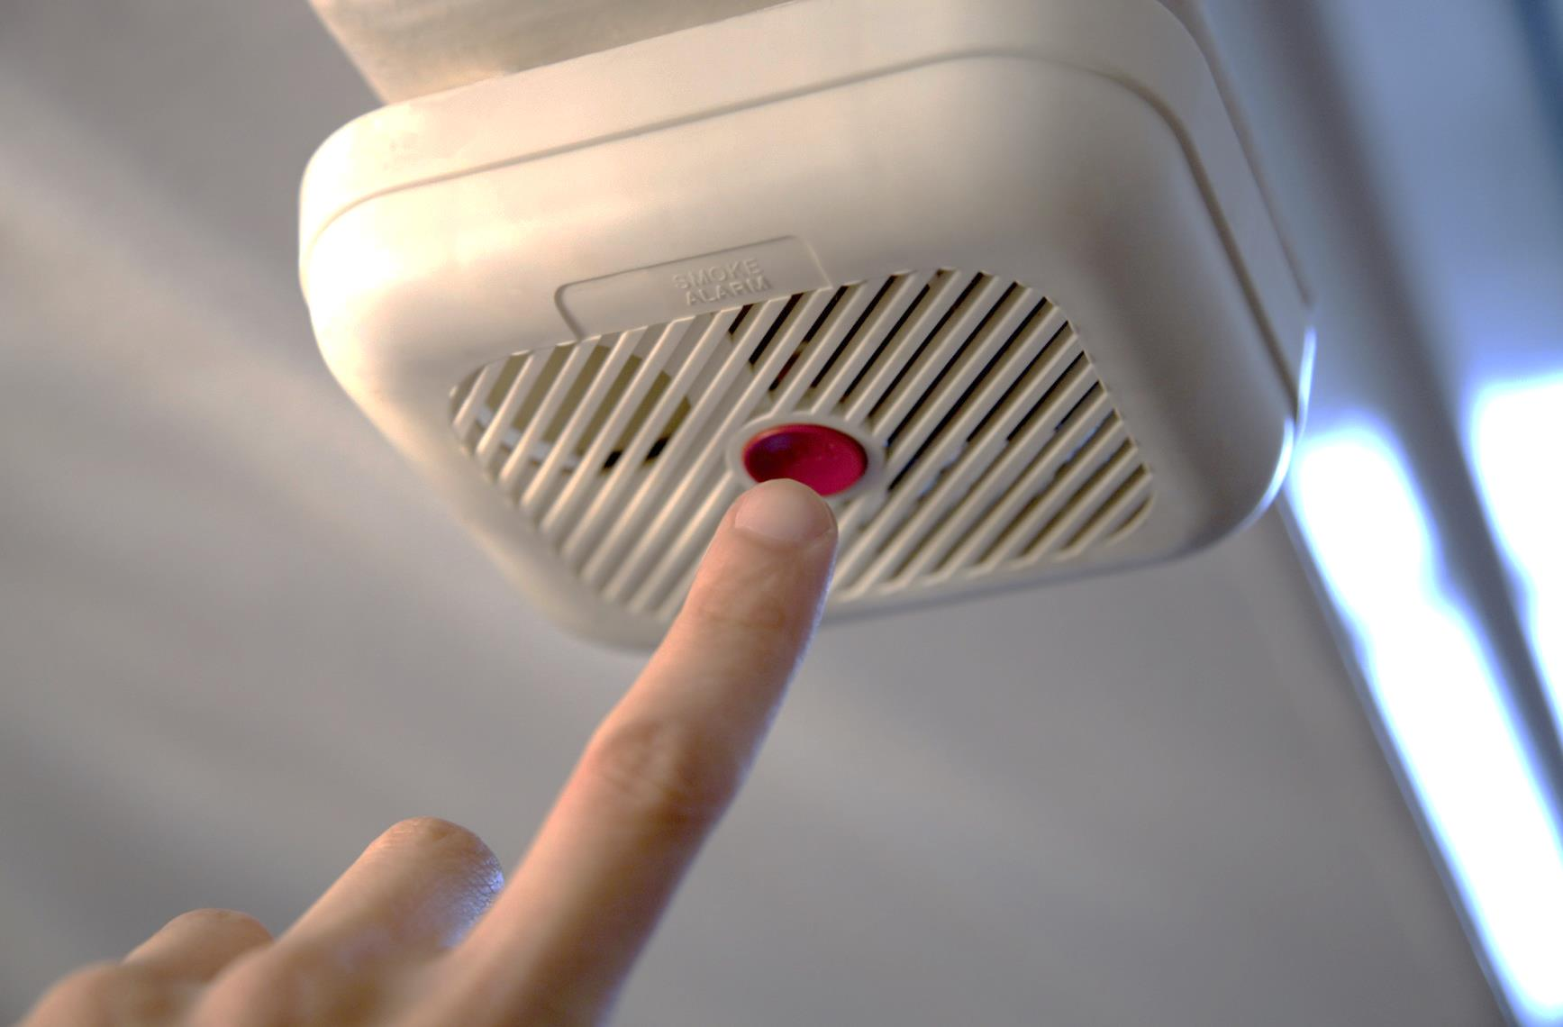

* **Install smoke alarms in every bedroom, outside each sleeping area and on every level of the home, including the basement.**

* **Interconnect your home’s smoke alarms. This way, when one sounds, they all sound.**
* **Teach children the sound of the smoke alarm and to exit the home/building when it sounds.**
* **Place alarms on the ceiling. If alarms are placed on the wall they must be no more than 12 inches below the ceiling.**

Did you know?

Smoke alarms should be tested monthly.

Smoke alarm batteries should be changed at least once a year.

All smoke alarms should be replaced every 10 years.

Working smoke alarms cut in half your risk of dying in a residential fire.

SMOKE ALARMS

WHAT YOU NEED TO KNOW ABOUT:

**sfm.dps.mn.gov**

**445 Minnesota St., Suite 145, St. Paul, MN 55101 Telephone: 651-201-7200 Fax: 651-215-0525**

