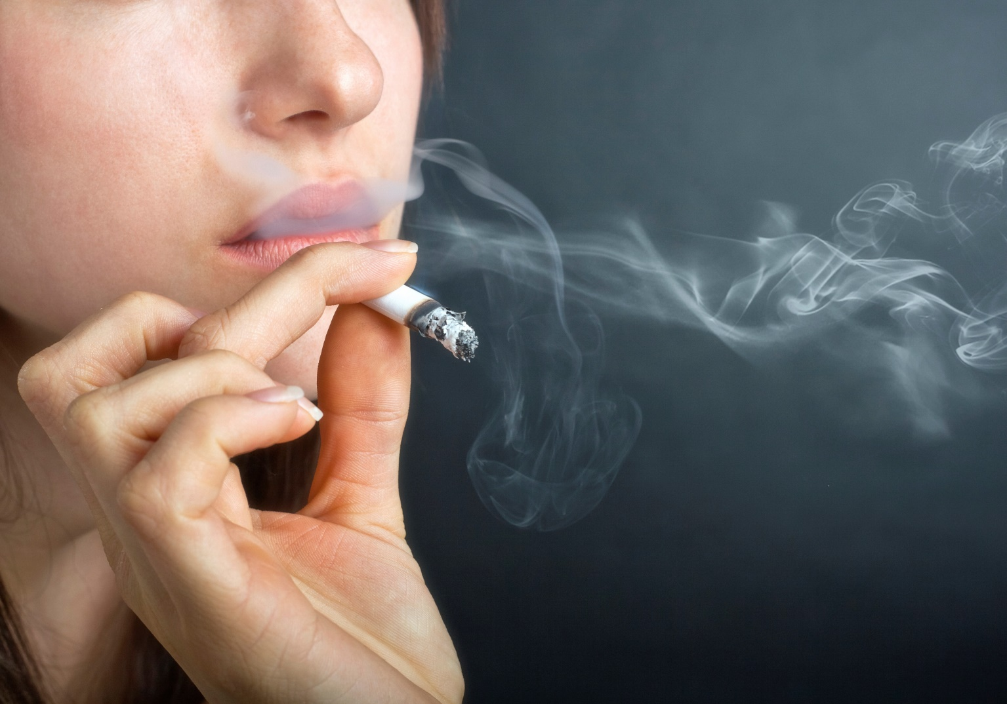

* **If you smoke, smoke outside.**

* **Discard of cigarettes in a deep, sturdy ashtray filled with water or sand.**
* **Do not discard cigarettes in vegetation like mulch, potted plants, peat moss or leaves.**
* **Do not smoke while using medical oxygen or near medical oxygen.**
* **Do not smoke while under the influence of drugs or alcohol.**

Did you know?

Careless smoking   
is the leading cause of fatal fires   
in Minnesota.

Most fires started   
by cigarettes started in living rooms, family rooms, dens or bedrooms.

Fires have occurred while e-cigarettes were being used, the battery was being charged, or the device was being transported.

SMOKING SAFETY TIPS

**YOUR DEPARTMENT WEBSITE**

**Your department address Telephone: XXX-XXX-XXXX Fax: XXX-XXX-XXXX**