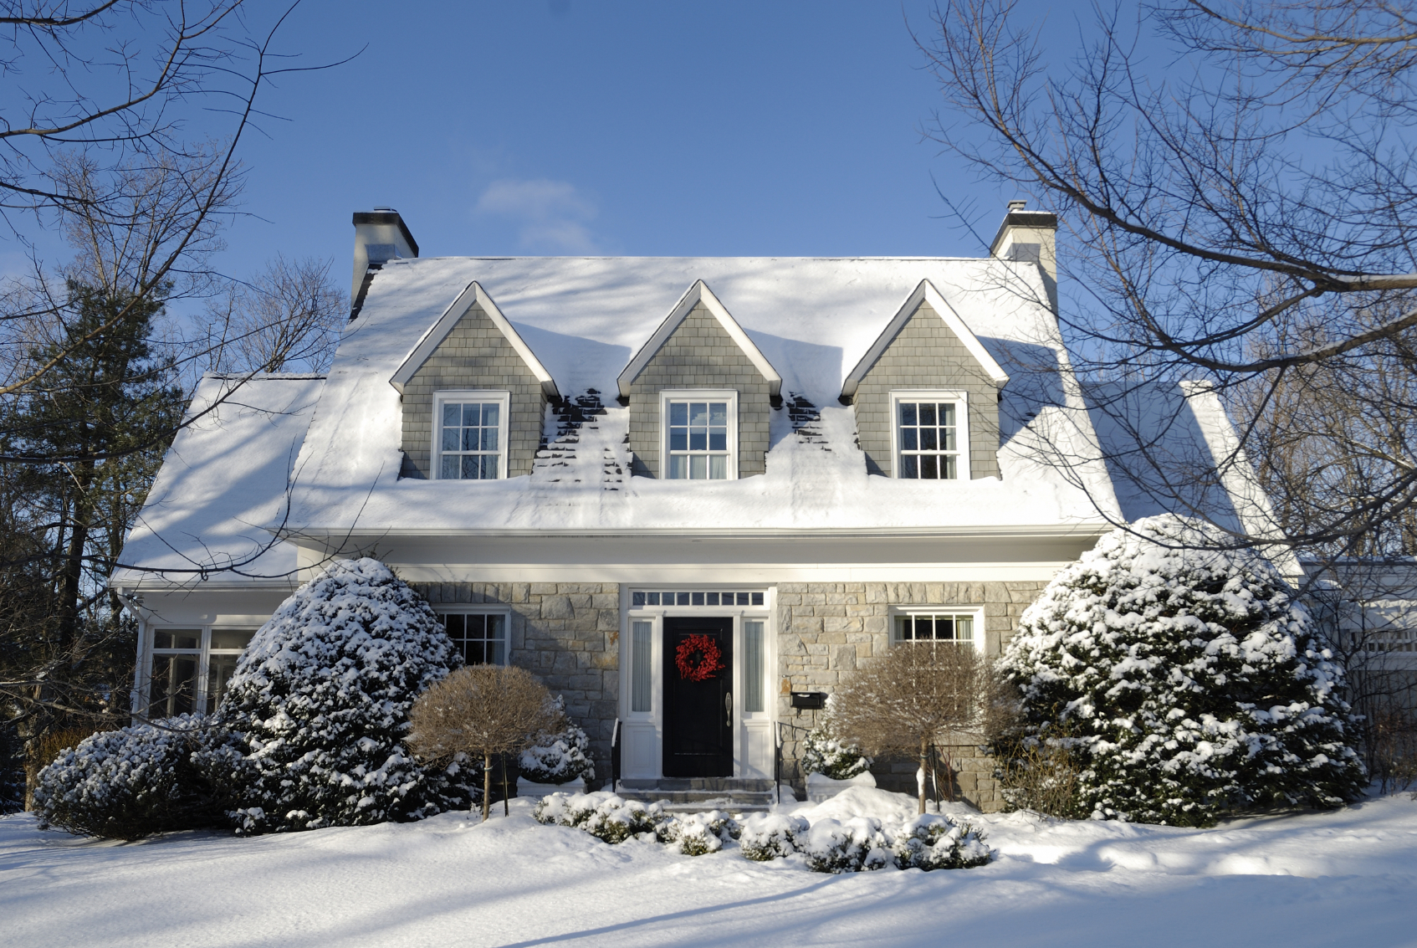

Ma ogtahay?

Dababka guriga intooda ugu badani waxay kacaan xilliga qaboobaha oo ay ugu badan yihiin bisha Janawari.

Sannad kasta gudaha Maraykanka waxa jira khasaare ka badan $2 bilyan oo ku yimaad hantida oo ay sababaan dababka ka kaca guriga xilliyada qaboobaha.

Sannadkii hore gudaha Minnesota, boqolkiiba 39 ee dabka dhimashada sababay ayaa waxay dhaceen inta lagu jiray bishii Oktoober, Noofamber iyo Diseembar.

* **Albaabka iyo daaqaddaha dabka looga fakado ka xaaq dhammaan wixii baraf ah iyo buunshada barafka.**

* **Ka nadiifi dhammaan dhuumaha bixinta hawada — goobta dabka, qalajiyaha, shoolladda iyo foornada — barafka buunshada, baraf adag iyo qashin ah.**
* **Marna ha u isticmaalin qalabka ololka sii daaya inaad ku dhalaaliso tubooyinka xarkakay.**
* **Isticmaal toosh, shamacyo ha isticmaalin, haddii ay korontadu kaa tagto.**
* **Uga fogee wax kasta oo guban kara ugu yaraan saddex fiit ilaha kulaylka; oo ha isticmaalin ofankaaga si aad ugu in kululeyso gurigaaga.**

DABABKA INTA BADAN KACA XILLIYADA QABOOBAHA

**YOUR DEPARTMENT WEBSITE**

**Your department address Telefoonka: XXX-XXX-XXXX Faakis: XXX-XXX-XXXX**