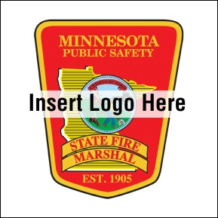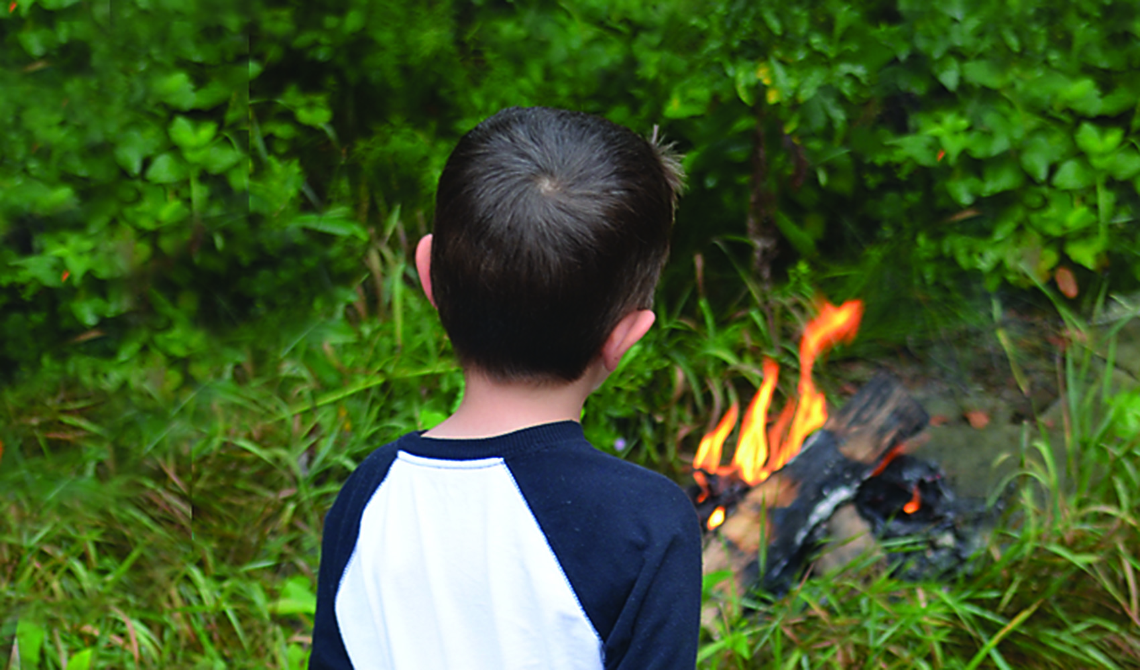

* **Be a good role model. Use fire safely and talk to your kids about the dangers of fire.**

* **Keep fire tools secured and locked up.**
* **Look for signs of fire misuse including unexplained scorch marks or melted areas in clothes, furniture, toys, paper and outside areas.**
* **Talk to your child if you notice signs of fire misuse and call 1-800-500-8897 for help.**

YOUTH FIRESETTING PREVENTION

Did you know?

Children between ages 10 and 17 account for about 50 percent of arson arrests.

In 2013, children started 300 fires in Minnesota.

Even if a child starts a small fire, it is a big deal. Fires can cause property damage, injury and death.

Help is available to stop this behavior.

**sfm.dps.mn.gov**

**445 Minnesota St., Suite 145, St. Paul, MN 55101 Telephone: 651-201-7200 Fax: 651-215-0525**