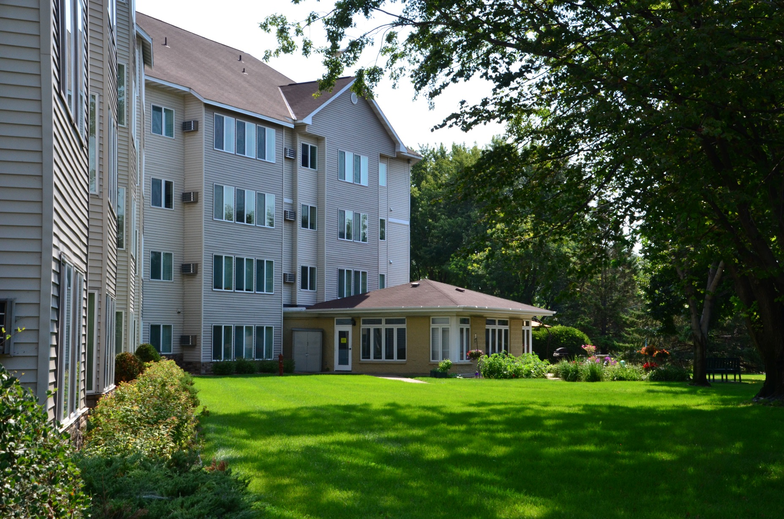

* **If the fire alarm sounds, take action.**

* **Open the door slightly to check for smoke. If there is no smoke, move to the exit; do not use the elevator.**
* **If there is smoke, close the door. Call 911. Move to the furthest window and turn on the light.**
* **If there is a fire in your unit, leave immediately and close the door behind you. Pull the fire alarm in the hallway if there is one. Call 911 when you are outside the building.**

APARTMENT LIVING

WHAT YOU SHOULD KNOW ABOUT

Did you know?

On average, more than 30 percent of structure fires occur in multi-family housing units.

When considering renting an apartment, check if the building has a fire sprinkler system.

Practice exiting two different ways from your apartment so that it comes naturally in an emergency.

**YOUR DEPARTMENT WEBSITE**

**Your department address Telephone: XXX-XXX-XXXX Fax: XXX-XXX-XXXX**